**OOP(Object-Oriented Programming)**

**1. Class and Object**

* **Class**: A blueprint or template for creating objects. It defines the properties (attributes) and behaviors (methods) that the objects will have.
* **Object**: An instance of a class. It is a real-world entity that has state (data) and behavior (actions).

**Example:**

// Class

class Dog {

// Properties (attributes)

String name;

String breed;

// Behavior (method)

void bark() {

System.out.println(name + " is barking!");

}

}

// Object

public class Main {

public static void main(String[] args) {

Dog myDog = new Dog(); // Creating an object of Dog class

myDog.name = "Buddy"; // Setting properties

myDog.breed = "Golden Retriever";

myDog.bark(); // Calling method

}

}

**Output**:

Buddy is barking!

**2. Encapsulation**

* Encapsulation means wrapping data (properties) and methods (behaviors) into a single unit (class).
* It also involves restricting direct access to some of the object's components (using private access modifier) and providing controlled access via methods (getters and setters).

**Example:**

class BankAccount {

private double balance; // Private property

// Public method to deposit money

public void deposit(double amount) {

if (amount > 0) {

balance += amount;

}

}

// Public method to get balance

public double getBalance() {

return balance;

}

}

public class Main {

public static void main(String[] args) {

BankAccount account = new BankAccount();

account.deposit(1000); // Deposit money

System.out.println("Balance: " + account.getBalance()); // Access balance

}

}

**Output**:

Balance: 1000.0

**3. Inheritance**

* Inheritance allows a class (child class) to inherit properties and methods from another class (parent class).
* It promotes code reusability.

**Example:**

// Parent class

class Animal {

void eat() {

System.out.println("This animal eats food.");

}

}

// Child class inheriting from Animal

class Dog extends Animal {

void bark() {

System.out.println("The dog barks.");

}

}

public class Main {

public static void main(String[] args) {

Dog myDog = new Dog();

myDog.eat(); // Inherited method

myDog.bark(); // Child class method

}

}

**Output**:

This animal eats food.

The dog barks.

**4. Polymorphism**

* Polymorphism means "many forms." It allows methods to behave differently based on the object that calls them.
* Two types: **Method Overloading** (compile-time) and **Method Overriding** (runtime).

**Example (Method Overriding):**

class Animal {

void sound() {

System.out.println("Animal makes a sound.");

}

}

class Dog extends Animal {

@Override

void sound() {

System.out.println("Dog barks.");

}

}

public class Main {

public static void main(String[] args) {

Animal myAnimal = new Dog(); // Polymorphism

myAnimal.sound(); // Calls Dog's sound() method

}

}

**Output**:

Dog barks.

**5. Abstraction**

* Abstraction means hiding complex implementation details and showing only the necessary features.
* It is achieved using **abstract classes** and **interfaces**.

**Example (Abstract Class):**

abstract class Animal {

abstract void sound(); // Abstract method (no body)

}

class Dog extends Animal {

@Override

void sound() {

System.out.println("Dog barks.");

}

}

public class Main {

public static void main(String[] args) {

Animal myDog = new Dog();

myDog.sound();

}

}

**Output**:

Dog barks.

**Summary of OOPs Concepts:**

1. **Class**: Blueprint for objects.
2. **Object**: Instance of a class.
3. **Encapsulation**: Wrapping data and methods, controlling access.
4. **Inheritance**: Reusing code by creating parent-child relationships.
5. **Polymorphism**: Same method behaves differently based on the object.
6. **Abstraction**: Hiding complexity, showing only essential features.

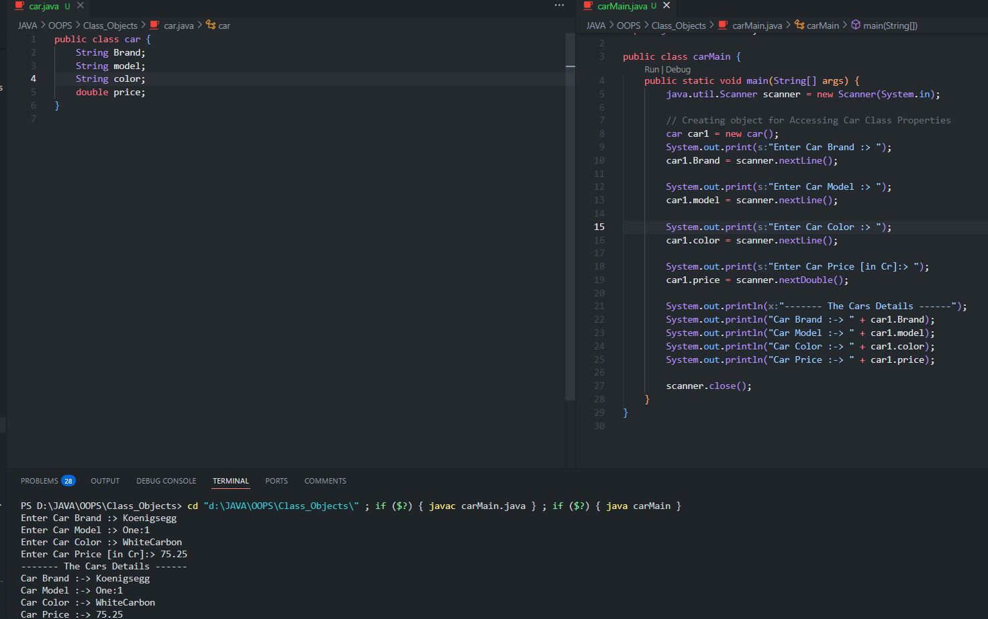

**📌 *Java Package Details***

In Java, **packages** are used to organize classes into **folders** (namespaces) to avoid naming conflicts and enhance code reusability.

**What is a Package?**

A **package** is a group of related classes and interfaces stored in the same directory.

💡 **Example:**

package mypackage; // Package declaration (must be the first line)

public class MyClass {

public void display() {

System.out.println("Hello from MyClass in mypackage");

}

}

**Types of Packages**

Java has **two** types of packages:

| **Package Type** | **Description** | **Example** |
| --- | --- | --- |
| **Built-in Package** | Provided by Java | java.util, java.io, java.sql |
| **User-defined Package** | Created by the programmer | com.bank, edu.university, mypackage |

**Creating & Using Packages**

**📌 (a) How to Create a Package?**

* Save the file inside a folder with the package name.
* Use the package keyword **at the beginning** of the file.

**✅ Example - Creating a Package (mypackage)**

📂 **Project Structure**

/JavaProjects

├── /mypackage

│ ├── MyClass.java

│ ├── AnotherClass.java

📜 **MyClass.java (inside mypackage)**

package mypackage; // Package declaration

public class MyClass {

public void showMessage() {

System.out.println("Hello from MyClass in mypackage!");

}

}

**📌 (b) How to Import a Package?**

If a class is inside another package, we must **import** it using import package_name.ClassName;.

**✅ Example - Using mypackage.MyClass in Another Package**

📂 **Project Structure**

/JavaProjects

├── /mypackage

│ ├── MyClass.java

├── /mainpackage

│ ├── Main.java

📜 **Main.java (in mainpackage)**

package mainpackage;

import mypackage.MyClass; // Importing MyClass from mypackage

public class Main {

public static void main(String[] args) {

MyClass obj = new MyClass(); // ✅ Object of MyClass

obj.showMessage(); // Output: Hello from MyClass in mypackage!

}

}

**Access Modifiers in Packages**

| **Modifier** | **Same Class** | **Same Package** | **Different Package (Subclass)** | **Different Package (No Inheritance)** |
| --- | --- | --- | --- | --- |
| **private** | ✅ Yes | ❌ No | ❌ No | ❌ No |
| **default (no modifier)** | ✅ Yes | ✅ Yes | ❌ No | ❌ No |
| **protected** | ✅ Yes | ✅ Yes | ✅ Yes | ❌ No |
| **public** | ✅ Yes | ✅ Yes | ✅ Yes | ✅ Yes |

📌 **Key Rules**:

* **private** members are **only accessible** inside the same class.
* **default** (no modifier) is accessible **within the same package only**.
* **protected** is accessible **in the same package** and **in subclasses in different packages**.
* **public** members are accessible **from anywhere**.

**Using Subpackages**

A **subpackage** is a package inside another package.

📂 **Project Structure**

/JavaProjects

├── /mypackage

│ ├── subpackage

│ │ ├── SubClass.java

│ ├── ParentClass.java

📜 **ParentClass.java**

package mypackage;

public class ParentClass {

protected void display() {

System.out.println("Protected method from ParentClass in mypackage");

}

}

📜 **SubClass.java**

package mypackage.subpackage;

import mypackage.ParentClass; // Importing ParentClass

public class SubClass extends ParentClass {

public void show() {

display(); // ✅ Allowed because of inheritance (protected access)

}

}

**Static Import**

If a class contains **static methods**, you can import them directly.

**✅ Example - Importing Math Methods**

import static java.lang.Math.*; // Static Import

public class Test {

public static void main(String[] args) {

System.out.println(sqrt(25)); // ✅ No need for Math.sqrt()

System.out.println(pow(2, 3)); // ✅ No need for Math.pow()

}

}

**Compiling & Running Packages**

**📌 (a) Compile a Package**

Navigate to the **parent directory** (where the package folder exists) and run:

javac -d . MyClass.java

* -d . tells the compiler to **create the package directory** if it doesn't exist.

**📌 (b) Running a Class from a Package**

Use the **fully qualified name**:

java mypackage.MyClass

**Advantages of Packages**

✔ **Avoids Name Conflicts** – Prevents duplicate class names across projects.  
✔ **Organized Code** – Helps manage large applications.  
✔ **Access Control** – Protects data using access modifiers.  
✔ **Reusability** – Allows code sharing between teams.

**🔹 Summary**

| **Feature** | **Example** |
| --- | --- |
| **Declare a package** | package mypackage; |
| **Import a package** | import mypackage.ClassName; |
| **Import all classes in a package** | import mypackage.*; |
| **Using static import** | import static java.lang.Math.*; |
| **Compile a package** | javac -d . MyClass.java |
| **Run a package class** | java mypackage.MyClass |

**🚀 Final Notes**

📌 **Use protected** when subclasses in different packages need access.  
📌 **Use public** when access is needed from anywhere.  
📌 **Always structure packages properly** for maintainability.

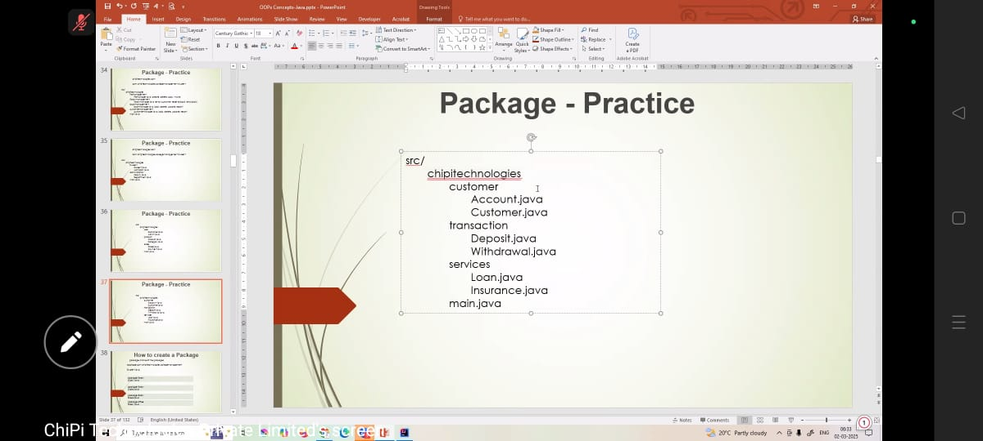

package JAVA.chipiTechnologies.Customer;  
  
public class Account {  
 private int accountID;  
 public double balance;  
  
 public Account(int *accountID*, double *balance*) {  
 this.accountID = *accountID*;  
 this.balance = *balance*;  
 }  
  
 public void showBalance () {  
 System.*out*.println("Account ID :-> " + accountID + ", Balance :-> " + balance);  
 }  
  
 public void updateBalance (double *amount*) {  
 balance += *amount*;  
 }  
}

package JAVA.chipiTechnologies.Customer;  
  
public class Customer {  
 private String name;  
 private int customerID;  
  
 public Customer (String *name*, int *customerID*) {  
 this.name = *name*;  
 this.customerID = *customerID*;  
 }  
  
 public void displayCustomer () {  
 System.*out*.println("CustomerID :-> " + customerID + ", Name :-> " + name);  
 }  
}

package JAVA.chipiTechnologies.Services;  
  
public class Insurance {  
 private String policyName;  
  
 public Insurance(String *policyName*) {  
 this.policyName = *policyName*;  
 }  
  
 public void showPolicy() {  
 System.*out*.println("Insurance policy :-> " + policyName);  
 }  
}

package JAVA.chipiTechnologies.Services;  
  
public class Loan {  
 private double loanAmount;  
  
 public Loan (double *loanAmount*){  
 this.loanAmount = *loanAmount*;  
 }  
  
 public void showLoanDetails() {  
 System.*out*.println("Loan Amount :-> " + loanAmount);  
 }  
}

package JAVA.chipiTechnologies.Transaction;  
import JAVA.chipiTechnologies.Customer.Account;  
  
public class Deposit {  
 private int accountID;  
 private double amount;  
  
 public Deposit(int *accountID*, double *amount*) {  
 this.accountID = *accountID*;  
 this.amount = *amount*;  
 }  
  
 public void makeDeposit (Account *account*) {  
 *account*.updateBalance(amount);  
 System.*out*.println("Deposited Amount :-> " + amount + " into Account ID :-> " + accountID);  
 *account*.showBalance();  
 }  
}

package JAVA.chipiTechnologies.Transaction;  
  
import JAVA.chipiTechnologies.Customer.Account;  
  
public class Withdraw {  
 private int accountId;  
 private double amount;  
  
 public Withdraw(int *accountId*, double *amount*) {  
 this.accountId = *accountId*;  
 this.amount = *amount*;  
 }  
  
 public void makeWithdraw(Account *account*) {  
 if (*account*.balance >= amount) {  
 *account*.updateBalance(-amount);  
 System.*out*.println("Withdraw " + amount + " from AccountID :-> " + accountId);  
 } else {  
 System.*out*.println("Insufficient funds in Account ID :-> " + accountId);  
 }  
 *account*.showBalance();  
 }  
}

package JAVA.chipiTechnologies;  
import JAVA.chipiTechnologies.Customer.Account;  
import JAVA.chipiTechnologies.Customer.Customer;  
import JAVA.chipiTechnologies.Services.Insurance;  
import JAVA.chipiTechnologies.Services.Loan;  
import JAVA.chipiTechnologies.Transaction.Deposit;  
import JAVA.chipiTechnologies.Transaction.Withdraw;  
  
import java.util.Scanner;  
public class main {  
 public static void main(String[] *args*) {  
 Scanner scanner = new Scanner(System.*in*);  
 Customer customer = new Customer("Aryan Shrivastava", 1);  
 customer.displayCustomer();  
  
 Account account = new Account(1, 10000.00);  
 account.showBalance();  
  
 Insurance insurance = new Insurance("Health Insurance");  
 insurance.showPolicy();  
  
 Loan loan = new Loan(200000.00);  
 loan.showLoanDetails();  
  
 Deposit deposit = new Deposit(1, 2500);  
 deposit.makeDeposit(account);  
  
 Withdraw withdraw = new Withdraw(1,1000);  
 withdraw.makeWithdraw(account);  
  
 scanner.close();  
 }  
}

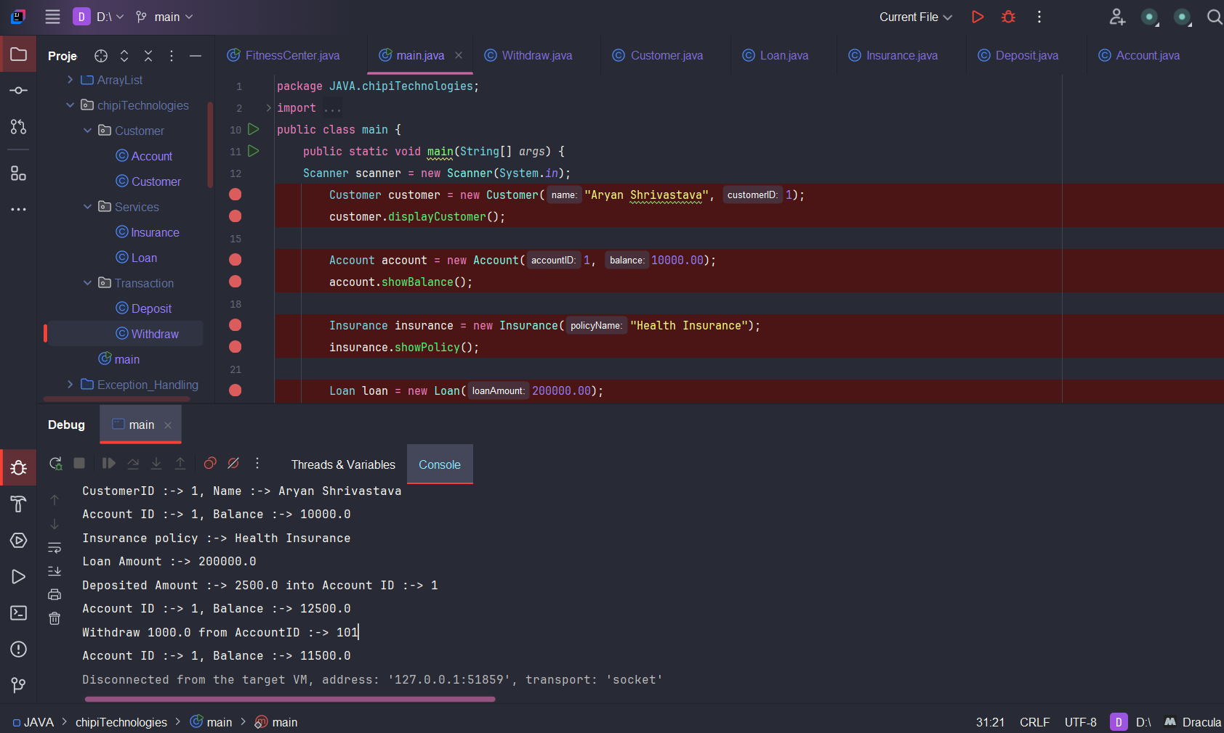

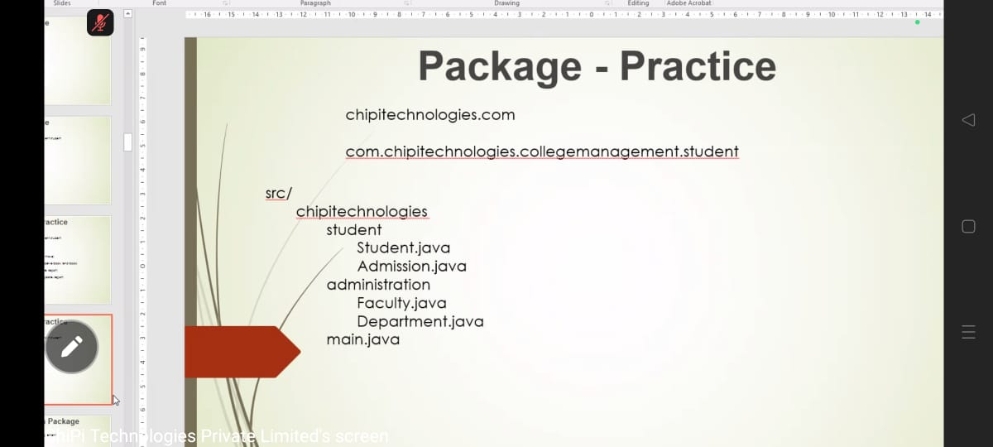

package JAVA.OOPS.Class_Objects.ChipiTechnologies.student;  
  
public class Student {  
 private int studentID;  
 private String studentName;  
  
  
 public void setStudentID(int *studentID*) {  
 this.studentID = *studentID*;  
 }  
  
 public int getStudentID() {  
 return studentID;  
 }  
  
 public void setStudentName(String *studentName*) {  
 this.studentName = *studentName*;  
 }  
  
 public String getStudentName() {  
 return studentName;  
 }  
  
 public void displayStudentDetails() {  
 System.*out*.println("Student Name :-> " + studentName);  
 System.*out*.println("Student ID :-> " + studentID);  
 }  
}

package JAVA.OOPS.Class_Objects.ChipiTechnologies.student;  
  
public class Admission {  
 public void admissionProcess(Student *student*) {  
 if (*student*.getStudentID() > 100) {  
 System.*out*.println("Admission Granted for " + *student*.getStudentName());  
 } else {  
 System.*out*.println("Admission Denied for " + *student*.getStudentName());  
 }  
 }  
}

package JAVA.OOPS.Class_Objects.ChipiTechnologies.administration;  
  
public class Department {  
 private String departmentName;  
  
 public void setDepartmentName (String *departmentName*) {  
 this.departmentName = *departmentName*;  
 }  
  
 public String getDepartmentName() {  
 return departmentName;  
 }  
  
 public void assignDepartment (String *studentName*) {  
 System.*out*.println(*studentName* + " has been assigned to the " + departmentName + " department.");  
 }  
}

package JAVA.OOPS.Class_Objects.ChipiTechnologies.administration;  
  
public class Faculty {  
 private String facultyName;  
  
 public String getFacultyName() {  
 return facultyName;  
 }  
  
 public void setFacultyName(String *facultyName*) {  
 this.facultyName = *facultyName*;  
 }  
  
 public void displayFacultyDetails () {  
 System.*out*.println("Faculty Name :-> " + facultyName);  
 }  
}

package JAVA.OOPS.Class_Objects.ChipiTechnologies;  
import JAVA.OOPS.Class_Objects.ChipiTechnologies.administration.Department;  
import JAVA.OOPS.Class_Objects.ChipiTechnologies.administration.Faculty;  
import JAVA.OOPS.Class_Objects.ChipiTechnologies.student.Admission;  
import JAVA.OOPS.Class_Objects.ChipiTechnologies.student.Student;  
  
import java.util.Scanner;  
public class main {  
 public static void main(String[] *args*) {  
 Scanner scanner = new Scanner(System.*in*);  
  
 System.*out*.print("Enter Student Name :-> ");  
 String studentName = scanner.nextLine();  
  
 System.*out*.print("Enter StudentID :-> ");  
 int studentID = scanner.nextInt();  
 scanner.nextLine();  
  
 Student student = new Student();  
 student.setStudentID(studentID);  
 student.setStudentName(studentName);  
  
 System.*out*.println("\n------- Student Details -------\n");  
 student.displayStudentDetails();  
  
 Admission admission = new Admission();  
 System.*out*.println("Checking Admission Status...");  
 admission.admissionProcess(student);  
  
 System.*out*.print("\nEnter Faculty Name :-> ");  
 String facultyName = scanner.nextLine();  
 Faculty faculty = new Faculty();  
 faculty.setFacultyName(facultyName);  
  
 System.*out*.println("\n------ Faculty Details -------\n");  
 faculty.displayFacultyDetails();  
  
 Department department = new Department();  
 System.*out*.print("\nEnter Department Name :-> ");  
 String departmentName = scanner.nextLine();  
 department.setDepartmentName(departmentName);  
 department.assignDepartment(student.getStudentName());  
  
 scanner.close();  
 }  
}

Enter Student Name :-> Aryan Shrivastava

Enter StudentID :-> 1001

------- Student Details -------

Student Name :-> Aryan Shrivastava

Student ID :-> 1001

Checking Admission Status...

Admission Granted for Aryan Shrivastava

Enter Faculty Name :-> Akash Shrivastava

------ Faculty Details -------

Faculty Name :-> Akash Shrivastava

Enter Department Name :-> Computer Science

Aryan Shrivastava has been assigned to the Computer Science department.

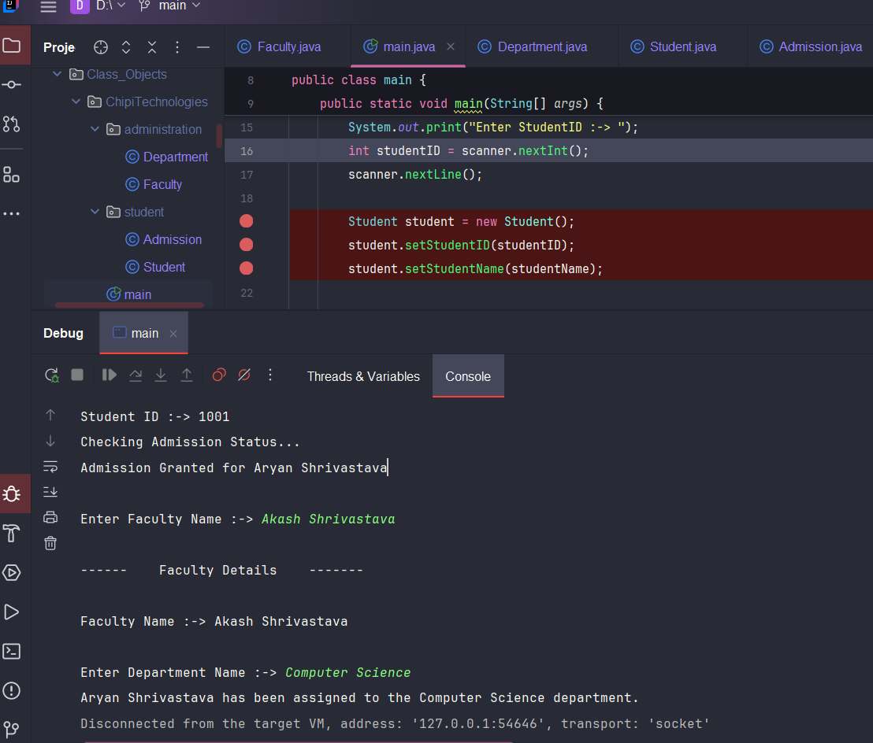

***Constructor***

A **constructor** is a special method in Java that is used to initialize objects. It is invoked automatically when an object is created.

**Types of Constructors in Java**

1️**Default Constructor (No-Argument Constructor)**  
2️**Parameterized Constructor**  
3️**Constructor Overloading**  
4️**Copy Constructor (Manually Implemented)**

**1️*Default Constructor (No-Argument Constructor)***

A constructor that takes no parameters and initializes default values.

**Example:**

class Car {

String brand;

int year;

// Default Constructor

public Car() {

System.out.println("Default Constructor Called!");

brand = "Unknown";

year = 0;

}

void display() {

System.out.println("Brand: " + brand + ", Year: " + year);

}

public static void main(String[] args) {

Car car1 = new Car(); // Default Constructor is invoked

car1.display();

}

}

**Output:**

Default Constructor Called!

Brand: Unknown, Year: 0

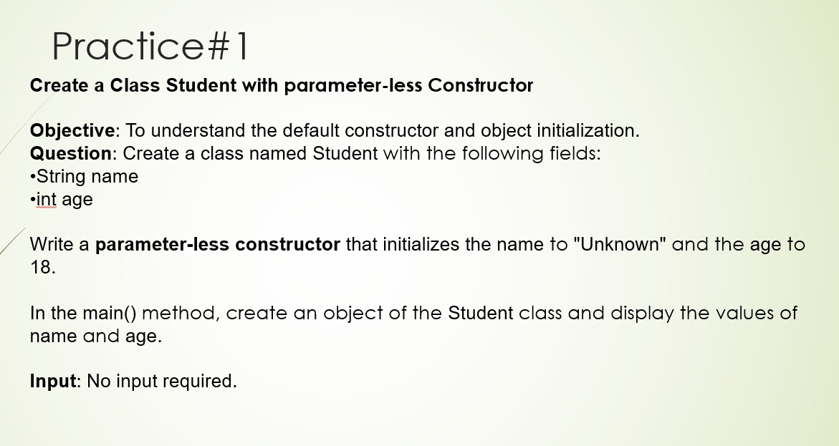

package JAVA.OOPS.Class_Objects.Student.students;  
  
public class student_Details {  
 public String Name;  
 public int age;  
  
 public student_Details() {  
 this.Name = "Unknown";  
 this.age = 23;  
 }  
}

package JAVA.OOPS.Class_Objects.Student.main;  
  
import JAVA.OOPS.Class_Objects.Student.students.student_Details;  
  
public class studentMain {  
 public static void main(String[] *args*) {  
 student_Details students = new student_Details();  
 System.*out*.println("Student Name :-> " + students.Name);  
 System.*out*.println("Student Age :-> " + students.age);  
 }  
}

Student Name :-> Unknown

Student Age :-> 23

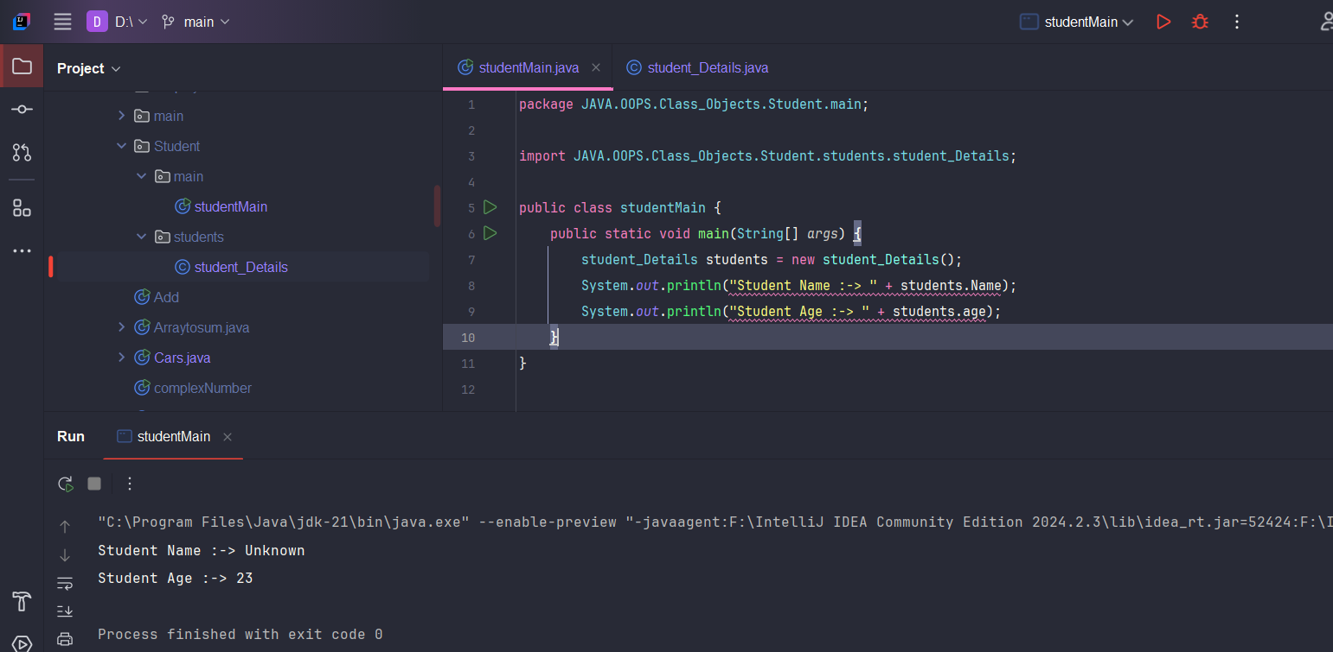

**2️*Parameterized Constructor***

A constructor that accepts parameters to initialize instance variables.

**Example:**

class Car {

String brand;

int year;

// Parameterized Constructor

public Car(String b, int y) {

brand = b;

year = y;

}

void display() {

System.out.println("Brand: " + brand + ", Year: " + year);

}

public static void main(String[] args) {

Car car1 = new Car("Toyota", 2022);

Car car2 = new Car("Honda", 2023);

car1.display();

car2.display();

}

}

**Output:**

Brand: Toyota, Year: 2022

Brand: Honda, Year: 2023

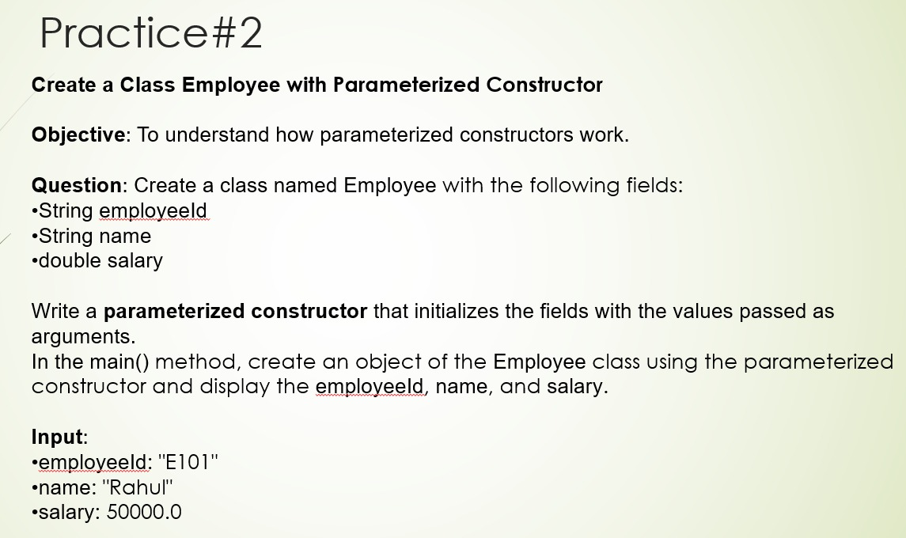

package JAVA.OOPS.Class_Objects.Employee.e_Details;  
  
public class employeeDetails {  
 String employeeID;  
 String name;  
 long salary;  
  
 public employeeDetails(String *employeeID*, String *name*, long *salary*) {  
 this.employeeID = *employeeID*;  
 this.name = *name*;  
 this.salary = *salary*;  
 }  
  
 public void display_employee_Details() {  
 System.*out*.println("--- Employee Details ---");  
 System.*out*.println("Employee ID :-> " + employeeID);  
 System.*out*.println("Employee Name :-> " + name);  
 System.*out*.println("Employee Salary :-> " + salary);  
 }  
}

package JAVA.OOPS.Class_Objects.Employee.main;  
import JAVA.OOPS.Class_Objects.Employee.e_Details.employeeDetails;  
  
import java.util.Scanner;  
public class employee_Main {  
 public static void main(String[] *args*) {  
 Scanner scanner = new Scanner(System.*in*);  
  
 System.*out*.print("Enter Employee ID :-> ");  
 String emp_Id = scanner.nextLine();  
  
 System.*out*.print("Enter Employee Name :-> ");  
 String emp_Name = scanner.nextLine();  
  
 System.*out*.print("Enter Employee Salary :-> ");  
 long emp_Salary = scanner.nextInt();  
  
 employeeDetails emp = new employeeDetails(emp_Id,emp_Name,emp_Salary);  
  
 emp.display_employee_Details();  
 scanner.close();  
 }  
}

Enter Employee ID :-> 1

Enter Employee Name :-> Aryan kumar Shrivastava

Enter Employee Salary :-> 100000

--- Employee Details ---

Employee ID :-> 1

Employee Name :-> Aryan kumar Shrivastava

Employee Salary :-> 100000

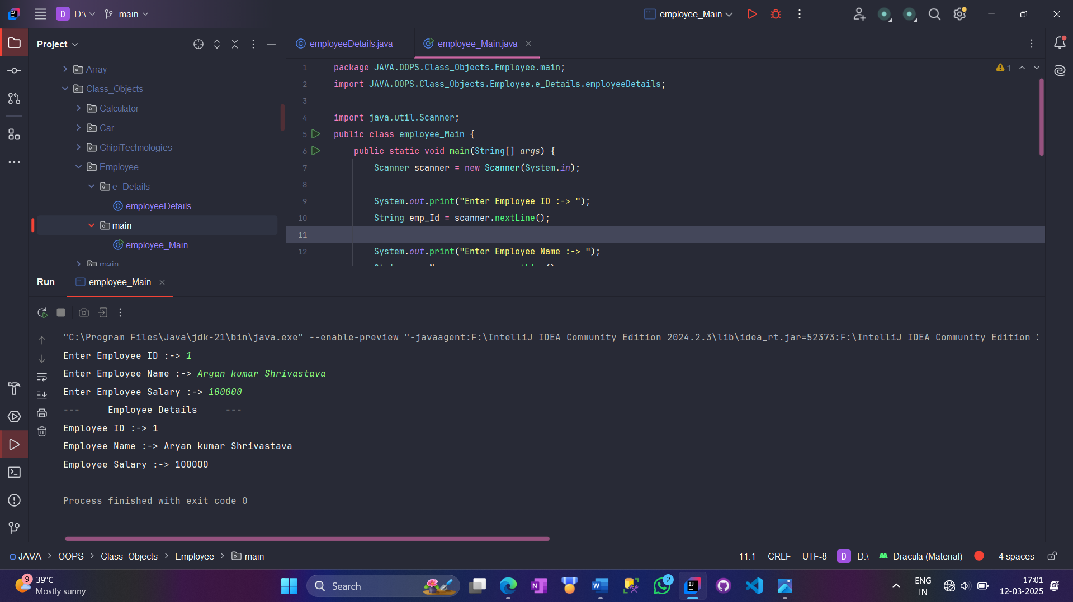

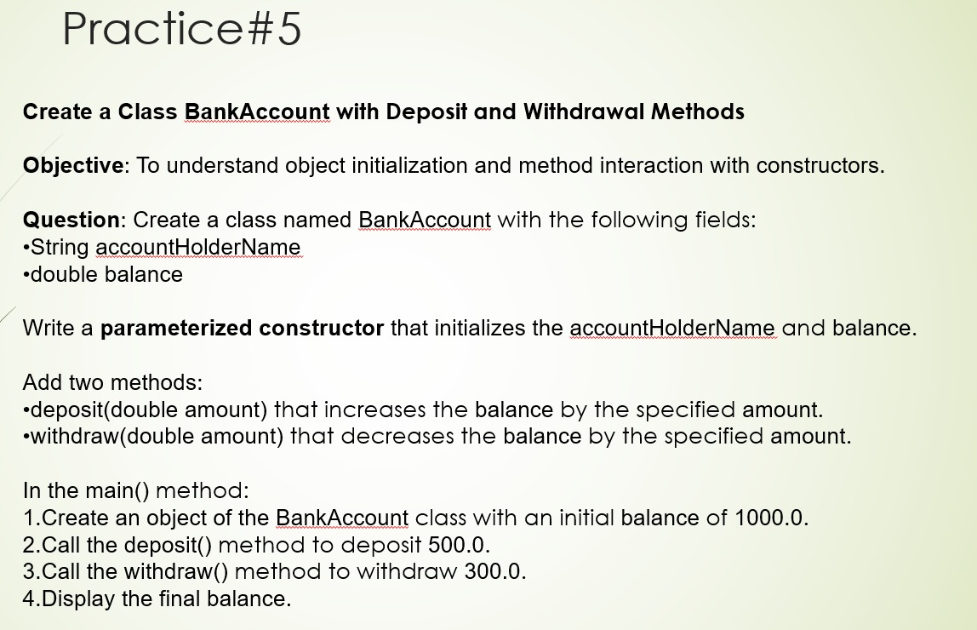

package JAVA.OOPS.Constructor.Account.bankAccount;  
  
public class bankAccount {  
 private String accountHolderName;  
 private double balance;  
  
 public bankAccount(String *accountHolderName*, double *balance*) {  
 this.accountHolderName = *accountHolderName*;  
 this.balance = *balance*;  
 }  
  
 public void deposit (double *amount*) {  
 try {  
 if (*amount* <= 0) {  
 throw new IllegalArgumentException("Deposit Amount must be positive or Greater than zero!");  
 }  
 balance += *amount*;  
 System.*out*.println("Deposited :-> " + *amount*);  
 } catch (Exception *e*) {  
 System.*out*.println("Deposit Error :-> " + *e*.getMessage());  
 }  
 }  
  
 public void withDraw (double *amount*) {  
 try {  
 if (*amount* <= 0) {  
 throw new IllegalArgumentException("Withdraw amount must be positive!");  
 }  
 if (*amount* > balance) {  
 throw new IllegalArgumentException("Insufficient Balance!");  
 }  
 balance -= *amount*;  
 System.*out*.println("Withdraw :-> " + *amount*);  
 } catch (Exception *e*) {  
 System.*out*.println("Withdrawal Error :-> " + *e*.getMessage());  
 }  
 }  
 public void displayBalance() {  
 System.*out*.println("Final Balance :-> " + balance);  
 }  
}

package JAVA.OOPS.Constructor.Account.main;  
import JAVA.OOPS.Constructor.Account.bankAccount.bankAccount;  
import java.util.Scanner;  
public class bankMain {  
 public static void main(String[] *args*) {  
 Scanner scanner = new Scanner(System.*in*);  
 System.*out*.print("Enter Account Holder Name :-> ");  
 String holderName = scanner.nextLine();  
  
 System.*out*.print("Enter Balance :-> ");  
 double balance = scanner.nextDouble();  
  
 bankAccount acc = new bankAccount(holderName, balance);  
 acc.deposit(200);  
 acc.withDraw(500);  
 acc.displayBalance();  
 scanner.close();  
 }  
}

Enter Account Holder Name :-> Aryan kumar shrivastava

Enter Balance :-> 1000

Deposited :-> 200.0

Withdraw :-> 500.0

Final Balance :-> 700.0

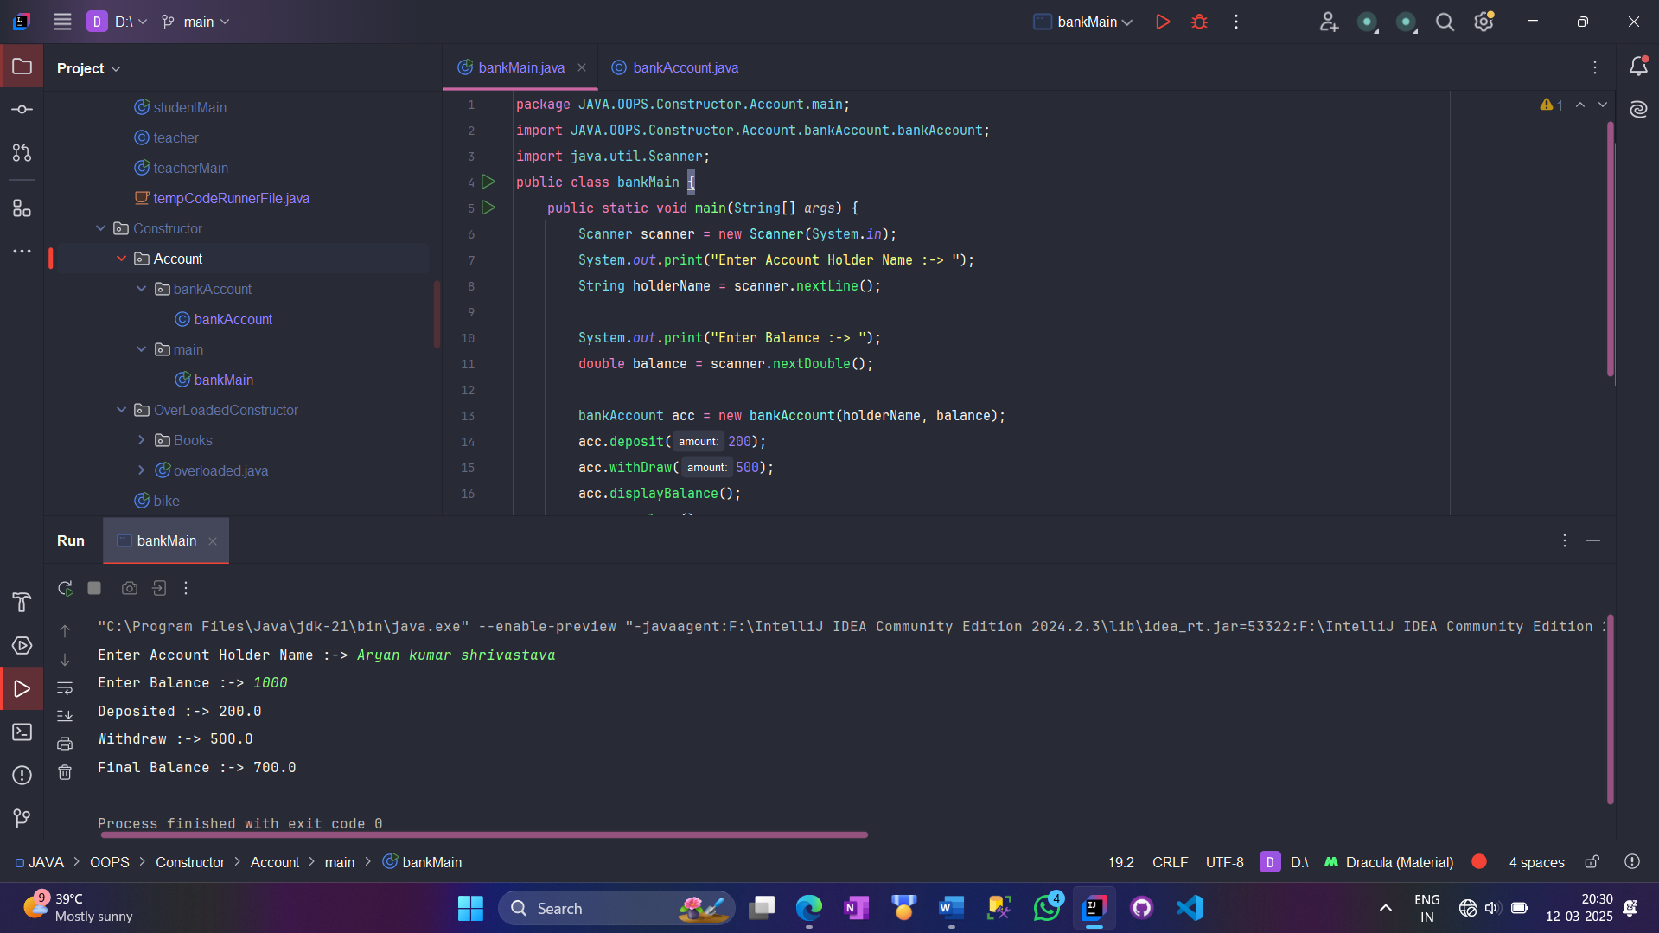

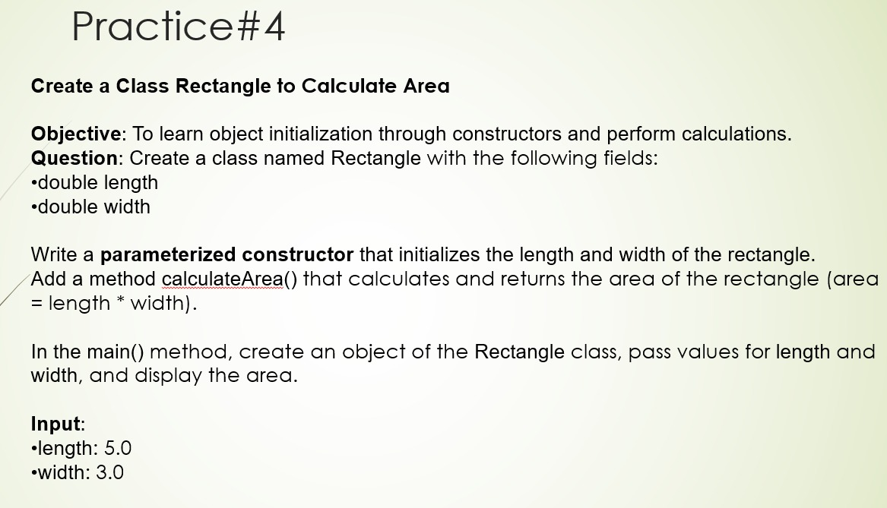

package JAVA.OOPS.Constructor.RectangleArea.rectangle;  
  
public class rectangle {  
 private int length;  
 private int width;  
  
 public void setLength(int *length*) {  
 this.length = *length*;  
 }  
 public int getLength() {  
 return length;  
 }  
  
 public void setWidth(int *width*) {  
 this.width = *width*;  
 }  
 public int getWidth() {  
 return width;  
 }  
}

package JAVA.OOPS.Constructor.RectangleArea.calculateArea;  
import JAVA.OOPS.Constructor.RectangleArea.rectangle.rectangle;  
public class calculateArea {  
 public int calculate(rectangle *rectangle*) {  
 return *rectangle*.getLength() * *rectangle*.getWidth();  
 }  
}

package JAVA.OOPS.Constructor.RectangleArea;  
import JAVA.OOPS.Constructor.RectangleArea.calculateArea.calculateArea;  
import JAVA.OOPS.Constructor.RectangleArea.rectangle.rectangle;  
  
import java.util.Scanner;  
public class rectangleMain {  
 public static void main(String[] *args*) {  
 Scanner scanner = new Scanner(System.*in*);  
 System.*out*.print("Enter Length :-> ");  
 int length = scanner.nextInt();  
  
 System.*out*.print("Enter Width :-> ");  
 int width = scanner.nextInt();  
  
 rectangle rect = new rectangle();  
 rect.setLength(length);  
 rect.setWidth(width);  
 calculateArea area = new calculateArea();  
 int areaOfRectangle = area.calculate(rect);  
  
 System.*out*.println("Area of Rectanlge is :-> " + areaOfRectangle);  
 scanner.close();  
 }  
}

Enter Length :-> 2

Enter Width :-> 3

Area of Rectanlge is :-> 6

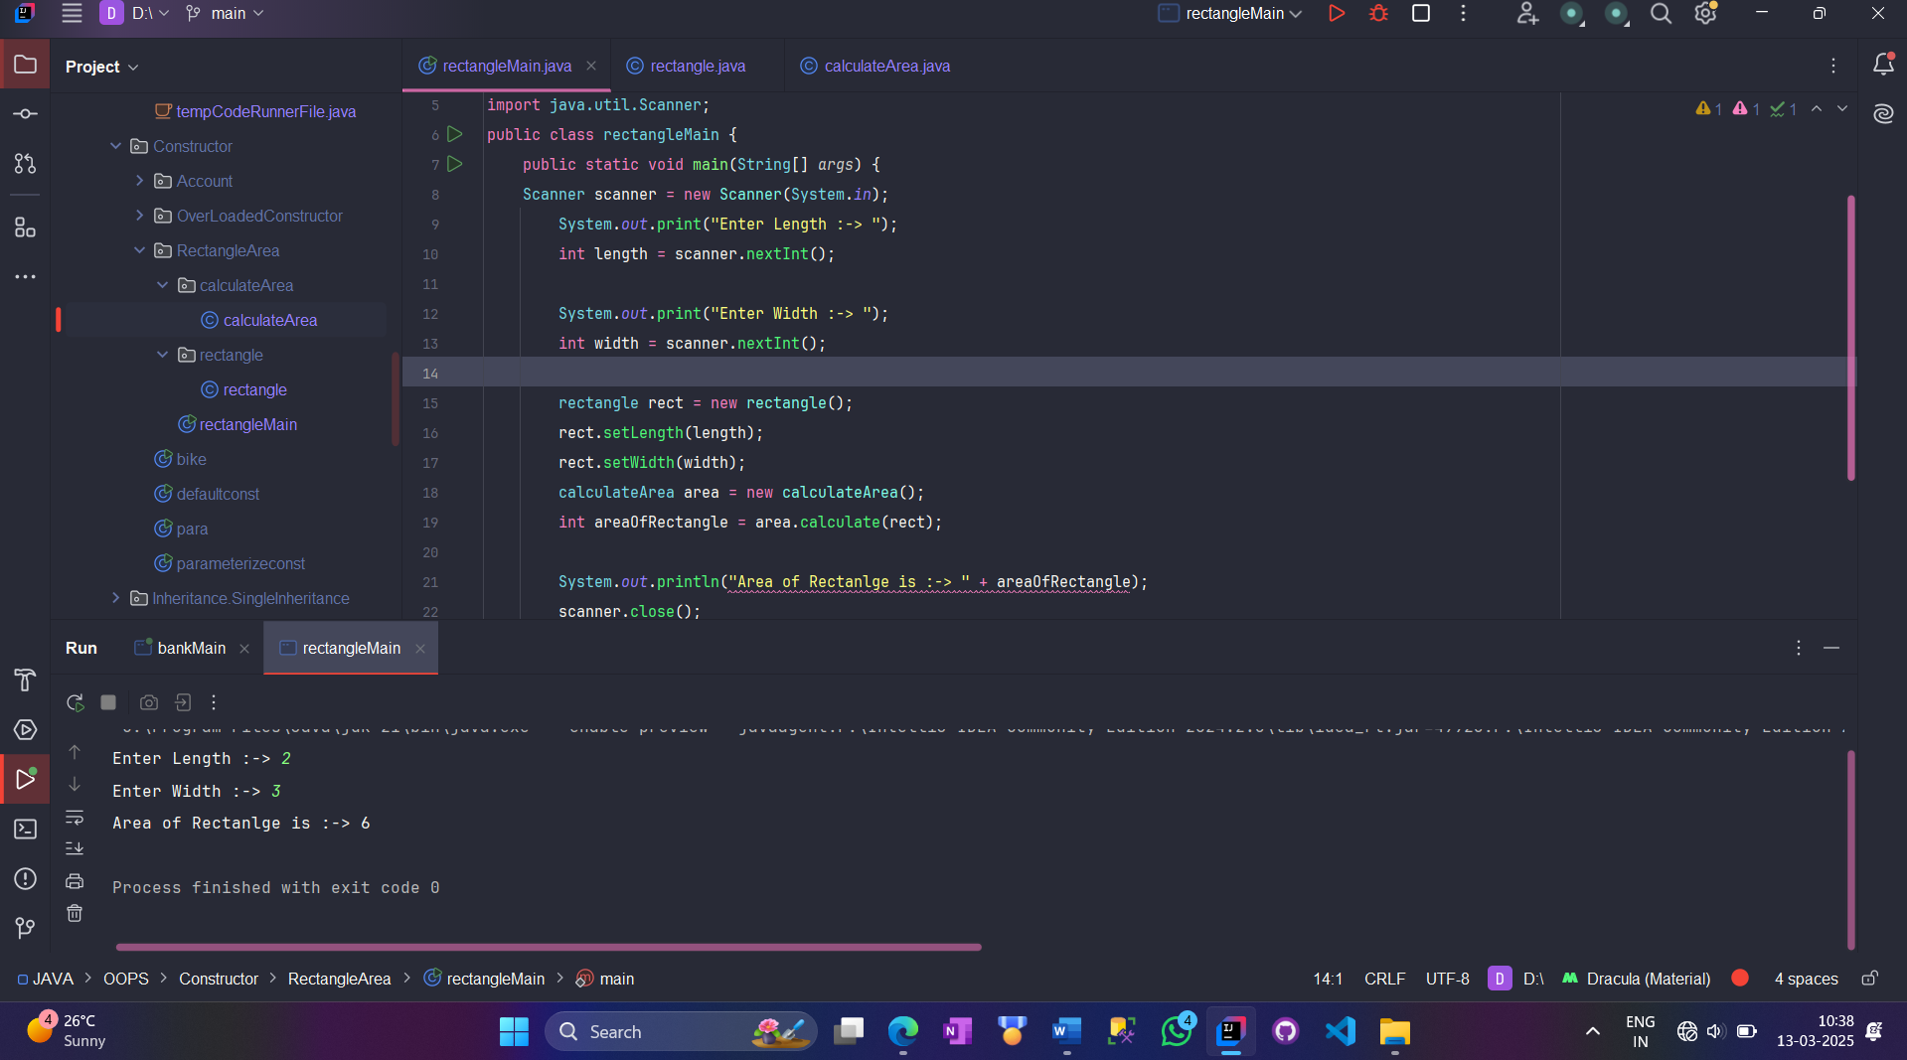

**3️*Constructor Overloading***

Java allows multiple constructors with different parameters.

**Example:**

class Car {

String brand;

int year;

double price;

// Default Constructor

public Car() {

brand = "Unknown";

year = 0;

price = 0.0;

}

// Constructor with one parameter

public Car(String b) {

brand = b;

year = 0;

price = 0.0;

}

// Constructor with two parameters

public Car(String b, int y) {

brand = b;

year = y;

price = 0.0;

}

// Constructor with three parameters

public Car(String b, int y, double p) {

brand = b;

year = y;

price = p;

}

void display() {

System.out.println("Brand: " + brand + ", Year: " + year + ", Price: $" + price);

}

public static void main(String[] args) {

Car car1 = new Car();

Car car2 = new Car("BMW");

Car car3 = new Car("Audi", 2021);

Car car4 = new Car("Mercedes", 2023, 50000.0);

car1.display();

car2.display();

car3.display();

car4.display();

}

}

**Output:**

Brand: Unknown, Year: 0, Price: $0.0

Brand: BMW, Year: 0, Price: $0.0

Brand: Audi, Year: 2021, Price: $0.0

Brand: Mercedes, Year: 2023, Price: $50000.0

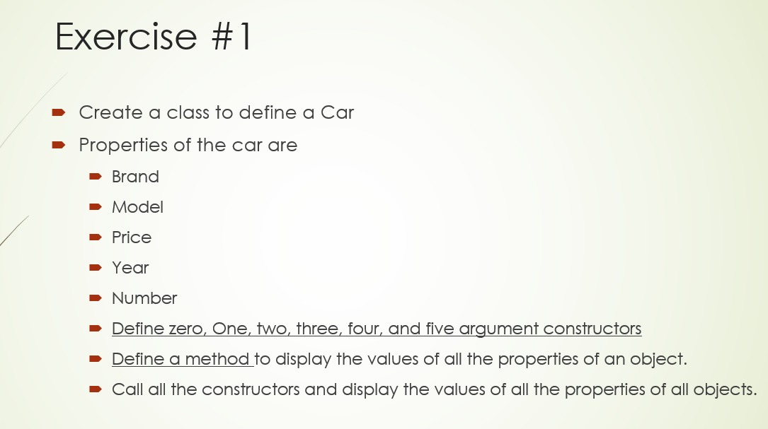

package JAVA.OOPS.Class_Objects.Car.carfeatures;  
  
public class car {  
 private String brand;  
 private String model;  
 private double price;  
 private int year;  
 private String number;  
  
 public car() {}  
  
 public car (String *brand*) {  
 this.brand = *brand*;  
 }  
  
 public car (String *brand*, String *model*) {  
 this.brand = *brand*;  
 this.model = *model*;  
 }  
 public car (String *brand*, String *model*, double *price*) {  
 this.brand = *brand*;  
 this.model = *model*;  
 this.price = *price*;  
 }  
 public car (String *brand*, String *model*, double *price*, int *year*) {  
 this.brand = *brand*;  
 this.model = *model*;  
 this.price = *price*;  
 this.year = *year*;  
 }  
 public car (String *brand*, String *model*, double *price*, int *year*, String *number*) {  
 this.brand = *brand*;  
 this.model = *model*;  
 this.price = *price*;  
 this.year = *year*;  
 this.number = *number*;  
 }  
 public String getBrand () {  
 return brand;  
 }  
 public String getModel() {  
 return model;  
 }  
 public double getPrice() {  
 return price;  
 }  
 public int getYear() {  
 return year;  
 }  
 public String getNumber () {  
 return number;  
 }  
}

package JAVA.OOPS.Class_Objects.Car.carDisplay;  
import JAVA.OOPS.Class_Objects.Car.carfeatures.car;  
public class display {  
 public static void carDetails(car *car*) {  
 System.*out*.println("------ Car Details ------");  
 System.*out*.println("Brand :> " + *car*.getBrand());  
 System.*out*.println("Model :> " + *car*.getModel());  
 System.*out*.println("Price :> " + *car*.getPrice());  
 System.*out*.println("Year :> " + *car*.getYear());  
 System.*out*.println("Number :> " + *car*.getNumber());  
 System.*out*.println("--------------------------------");  
 }  
}

package JAVA.OOPS.Class_Objects.Car;  
import JAVA.OOPS.Class_Objects.Car.carDisplay.display;  
import JAVA.OOPS.Class_Objects.Car.carfeatures.car;  
import java.util.Scanner;  
public class main {  
 public static void main(String[] *args*) {  
 Scanner scanner = new Scanner(System.*in*);  
 System.*out*.print("Enter Car Brand :-> ");  
 String brand = scanner.nextLine();  
  
 System.*out*.print("Enter Car Model :-> ");  
 String model = scanner.nextLine();  
  
 System.*out*.print("Enter Car Price :-> ");  
 double price = scanner.nextDouble();  
  
 System.*out*.print("Enter Car Year :-> ");  
 int year = scanner.nextInt();  
 scanner.nextLine();  
  
 System.*out*.print("Enter Car Number :-> ");  
 String number = scanner.nextLine();  
  
 System.*out*.println("------------------------");  
 car car1 = new car();  
 display.*carDetails*(car1);  
 car car2 = new car(brand);  
 display.*carDetails*(car2);  
 car car3 = new car(brand, model);  
 display.*carDetails*(car3);  
 car car4 = new car(brand, model, price);  
 display.*carDetails*(car4);  
 car car5 = new car(brand, model, price, year);  
 display.*carDetails*(car5);  
 car car6 = new car(brand, model, price, year, number);  
 display.*carDetails*(car6);  
   
 scanner.close();  
 }  
}

Enter Car Brand :-> Koeingsegg

Enter Car Model :-> one.1

Enter Car Price :-> 1999900.00

Enter Car Year :-> 2025

Enter Car Number :-> IND3000

------------------------

------ Car Details ------

Brand :> null

Model :> null

Price :> 0.0

Year :> 0

Number :> null

--------------------------------

------ Car Details ------

Brand :> Koeingsegg

Model :> null

Price :> 0.0

Year :> 0

Number :> null

--------------------------------

------ Car Details ------

Brand :> Koeingsegg

Model :> one.1

Price :> 0.0

Year :> 0

Number :> null

--------------------------------

------ Car Details ------

Brand :> Koeingsegg

Model :> one.1

Price :> 1999900.0

Year :> 0

Number :> null

--------------------------------

------ Car Details ------

Brand :> Koeingsegg

Model :> one.1

Price :> 1999900.0

Year :> 2025

Number :> null

--------------------------------

------ Car Details ------

Brand :> Koeingsegg

Model :> one.1

Price :> 1999900.0

Year :> 2025

Number :> IND3000

--------------------------------

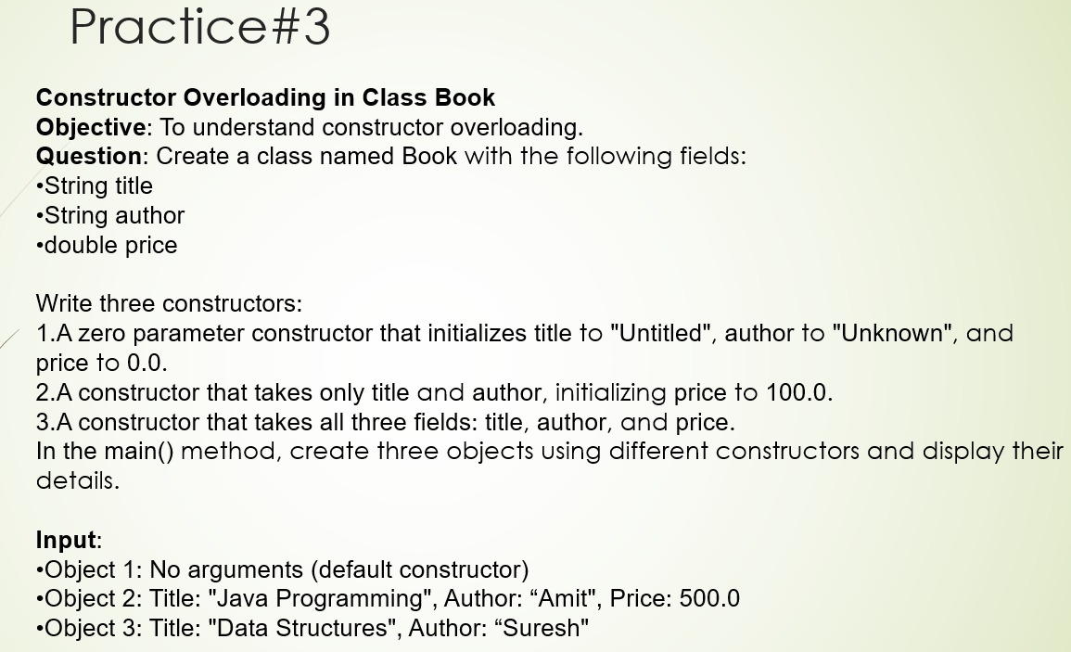

package JAVA.OOPS.Constructor.OverLoadedConstructor.Books;  
  
public class Book {  
 String title;  
 String author;  
 double price;  
  
 Book() {  
 title = "Untitled";  
 author = "Unknown";  
 price = 0.0;  
 }  
 Book (String *title*, String *author*) {  
 this.title = *title*;  
 this.author = *author*;  
 price = 100.0;  
 }  
 Book (String *title*, String *author*, double *price*) {  
 this.title = *title*;  
 this.author = *author*;  
 this.price = *price*;  
 }  
}

package JAVA.OOPS.Constructor.OverLoadedConstructor.Books;  
  
import java.util.Scanner;  
  
public class bookMain {  
 public static void main(String[] *args*) {  
 Scanner scanner = new Scanner(System.*in*);  
 System.*out*.print("Enter Book Title :-> ");  
 String title = scanner.nextLine();  
  
 System.*out*.print("Enter Book Author Name :-> ");  
 String author = scanner.nextLine();  
  
 System.*out*.print("Enter Book Price :-> ");  
 double price = scanner.nextDouble();  
  
 Book book1 = new Book();  
 System.*out*.println("------ Books Details ------");  
 System.*out*.println("Book's Title :> " + book1.title);  
 System.*out*.println("Book's Author :> " + book1.author);  
 System.*out*.println("Book's Price :> " + book1.price);  
 System.*out*.println("---------------------------------");  
  
 Book book2 = new Book(title, author);  
 System.*out*.println("------ Books Details ------");  
 System.*out*.println("Book's Title :> " + book2.title);  
 System.*out*.println("Book's Author :> " + book2.author);  
 System.*out*.println("Book's Price :> " + book2.price);  
 System.*out*.println("---------------------------------");  
  
 Book book3 = new Book(title, author, price);  
 System.*out*.println("------ Books Details ------");  
 System.*out*.println("Book's Title :> " + book3.title);  
 System.*out*.println("Book's Author :> " + book3.author);  
 System.*out*.println("Book's Price :> " + book3.price);  
 System.*out*.println("---------------------------------");  
 scanner.close();  
 }  
}

Enter Book Title :-> Chaava

Enter Book Author Name :-> Sambhaji Maharaj

Enter Book Price :-> 999.0

------ Books Details ------

Book's Title :> Untitled

Book's Author :> Unknown

Book's Price :> 0.0

---------------------------------

------ Books Details ------

Book's Title :> Chaava

Book's Author :> Sambhaji Maharaj

Book's Price :> 100.0

---------------------------------

------ Books Details ------

Book's Title :> Chaava

Book's Author :> Sambhaji Maharaj

Book's Price :> 999.0

---------------------------------

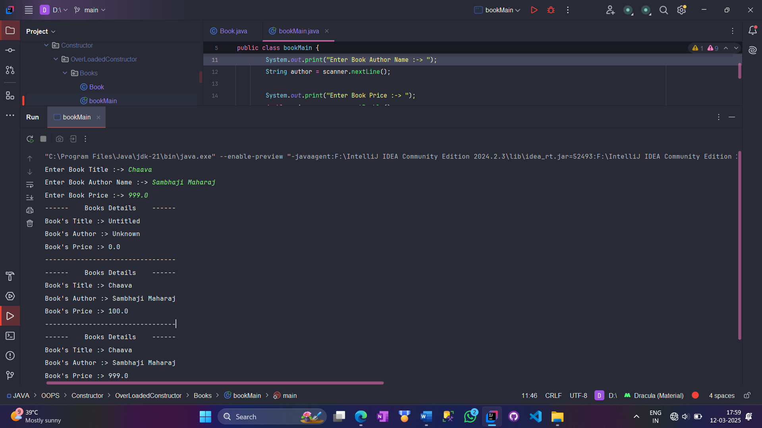

**4️*Copy Constructor***

Java does not provide a built-in copy constructor, but we can manually create one.

**Example:**

class Car {

String brand;

int year;

// Parameterized Constructor

public Car(String b, int y) {

brand = b;

year = y;

}

// Copy Constructor

public Car(Car obj) {

this.brand = obj.brand;

this.year = obj.year;

}

void display() {

System.out.println("Brand: " + brand + ", Year: " + year);

}

public static void main(String[] args) {

Car car1 = new Car("Tesla", 2022);

Car car2 = new Car(car1); // Copy constructor is invoked

car1.display();

car2.display();

}

}

**Output:**

Brand: Tesla, Year: 2022

Brand: Tesla, Year: 2022

**Key Points About Constructors**

✅ A constructor **does not have a return type**, not even void.  
✅ If no constructor is defined, **Java provides a default constructor**.  
✅ **Overloaded constructors** allow different ways of initializing an object.  
✅ **Copy constructor** helps create a duplicate object with the same values.

**When to Use Each Type?**

✔ **Default Constructor** → When you want to initialize with default values.  
✔ **Parameterized Constructor** → When you need to pass initial values while creating an object.  
✔ **Constructor Overloading** → When you want multiple ways to initialize an object.  
✔ **Copy Constructor** → When you need to create a copy of an existing object.

***Nested Class***

A **nested class** in Java means a class inside another class. This helps in organizing the code better and keeping related things together.

**Types of Nested Classes in Java**

Java has **two types** of nested classes:

1️**Static Nested Class**  
2️ **Non-static Nested Class (Inner Class)**

* **Member Inner Class**
* **Local Inner Class**
* **Anonymous Inner Class**

**1. Static Nested Class**

* This is a **static class inside another class**.
* It **can access only static members** of the outer class.
* **No need to create an object of the outer class** to use it.

**✅ Example**

class Outer {

static String message = "Hello from Outer Class";

static class Inner {

void display() {

System.out.println("Inside Static Inner Class: " + message);

}

}

}

public class Main {

public static void main(String[] args) {

Outer.Inner obj = new Outer.Inner(); // Directly creating inner class object

obj.display();

}

}

**🔹 Output:**

Inside Static Inner Class: Hello from Outer Class

package JAVA.OOPS.NestedClass.Static;  
  
public class Outer {  
 static int *data* = 50;  
 int nonStaticData = 100;  
  
 static class StaticNested {  
 void show () {  
 System.*out*.println("Data :-> " + *data*);  
 *//The non-static member of outer class can not be used inside the nested static class  
 //System.out.println("Non-Static Member Data :-> " + nonStaticData);* }  
 }  
}

package JAVA.OOPS.NestedClass.Static;  
  
public class OuterMain {  
 public static void main(String[] *args*) {  
 *//Object of the Nested Static class can be created without having an Object of the Outer Class* Outer.StaticNested obj = new Outer.StaticNested();  
 obj.show();  
 }  
}

Data :-> 50

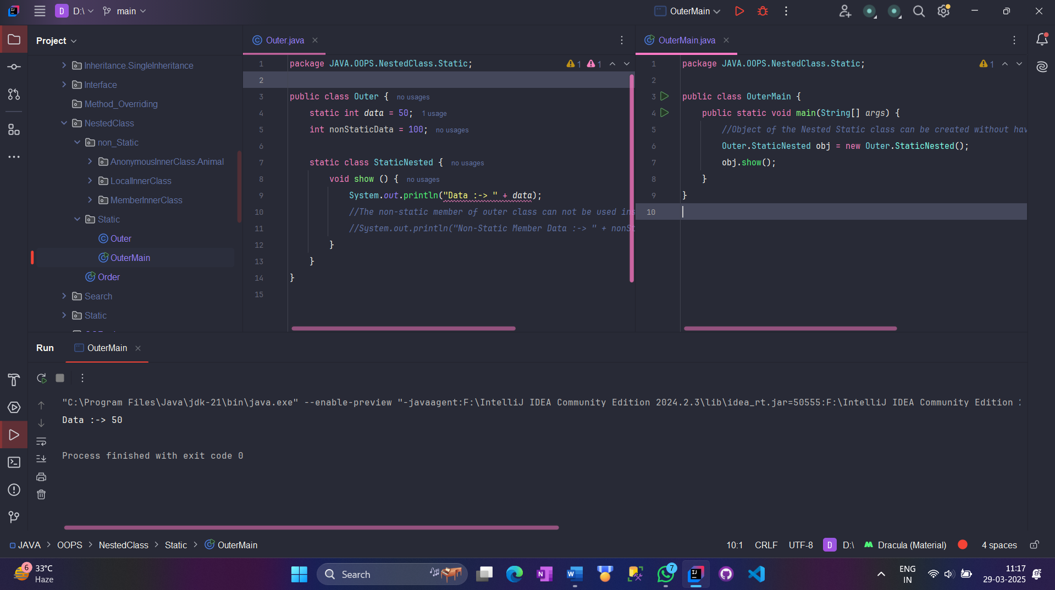

**2. Member Inner Class**

* This is a **normal (non-static) class inside another class**.
* It **can access all members of the outer class**.
* **You must create an object of the outer class first** to use it.

**✅ Example**

class Outer {

private String message = "Hello from Outer Class";

class Inner {

void display() {

System.out.println("Inside Member Inner Class: " + message);

}

}

}

public class Main {

public static void main(String[] args) {

Outer outer = new Outer();

Outer.Inner inner = outer.new Inner(); // Requires outer class object

inner.display();

}

}

**🔹 Output:**

Inside Member Inner Class: Hello from Outer Class

package JAVA.OOPS.NestedClass.Static.MemberInnerClass.Car;  
*//Nested Class - Car-Engine Example*public class Car {  
 private String model;  
 *//Constructor* Car(String *model*) {  
 this.model = *model*;  
 }  
 *//Member Inner Class* class Engine {  
 void start () {  
 System.*out*.println(model + "Engine is Starting... ");  
 }  
 }  
}

package JAVA.OOPS.NestedClass.Static.MemberInnerClass.Car;  
  
public class CarMain {  
 public static void main(String[] *args*) {  
 Car car = new Car("BMW");  
 Car.Engine engine = car.new Engine();  
 engine.start();  
 }  
}

BMW Engine is Starting...

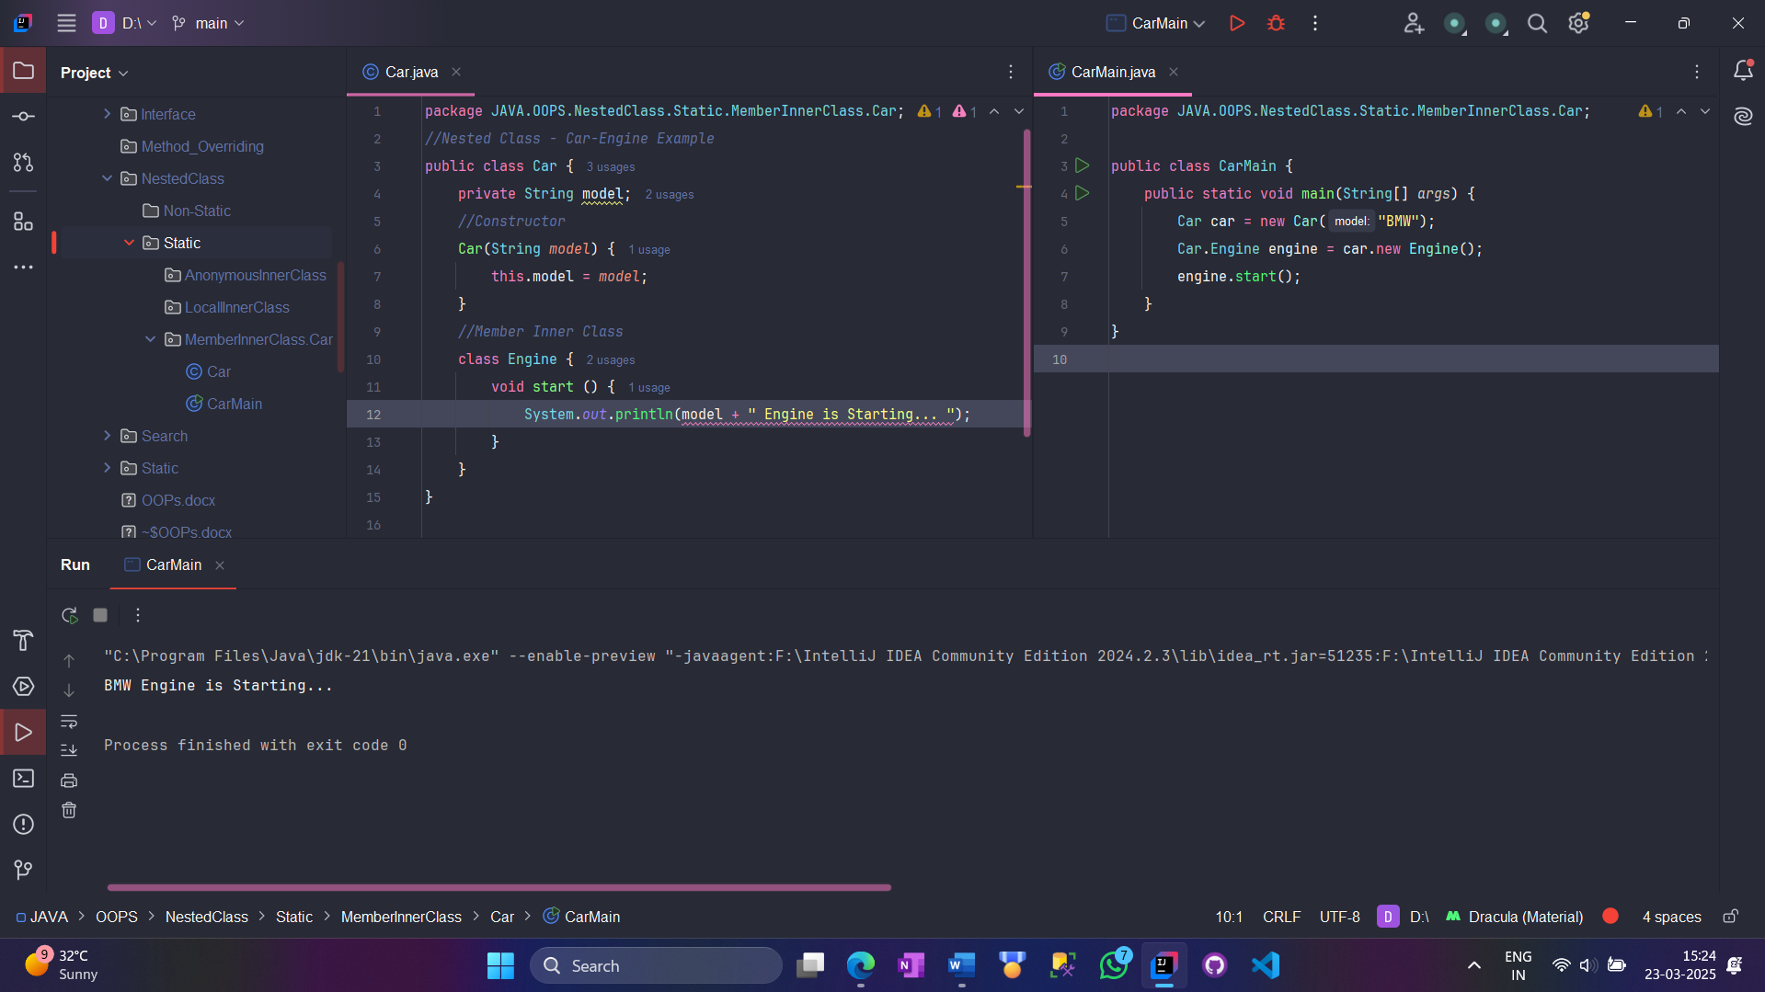

**3. Local Inner Class**

* This is a **class inside a method**.
* It **can only be used inside that method**.

**✅ Example**

class Outer {

void outerMethod() {

System.out.println("Inside Outer Method");

class Inner {

void innerMethod() {

System.out.println("Inside Local Inner Class");

}

}

Inner obj = new Inner();

obj.innerMethod();

}

}

public class Main {

public static void main(String[] args) {

Outer outer = new Outer();

outer.outerMethod();

}

}

**🔹 Output:**

Inside Outer Method

Inside Local Inner Class

package JAVA.OOPS.NestedClass.Static.LocallInnerClass.BankAccount;  
  
public class BankAccount {  
 private double balance = 5000;  
  
 void deposit (double *amount*) {  
 *//Local Inner Class inside a method* class Transaction {  
 void processes () {  
 System.*out*.println("Current Balance :-> " + balance);  
 balance += *amount*;  
 System.*out*.println("Deposited :-> " + *amount*);  
 System.*out*.println("Updated Balance :-> " + balance);  
 }  
 }  
 Transaction transaction = new Transaction();  
 transaction.processes();  
 }  
}

package JAVA.OOPS.NestedClass.Static.LocallInnerClass.BankAccount;  
  
public class BankAccountMain {  
 public static void main(String[] *args*) {  
 BankAccount account = new BankAccount();  
 account.deposit(1500);  
 }  
}

Current Balance :-> 5000.0

Deposited :-> 1500.0

Updated Balance :-> 6500.0

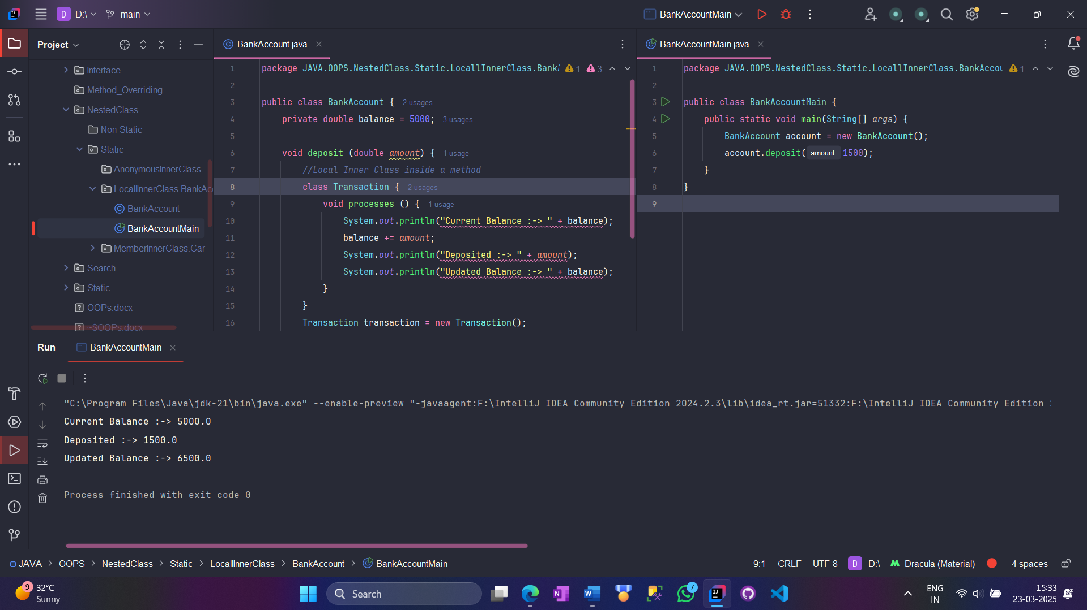

package JAVA.OOPS.NestedClass.Static.LocallInnerClass.Bank;  
  
public class BankAcc {  
 private double balance = 5000; *//Initial Balance  
   
 //Deposit Method with Local Inner Class* void deposit (double *amount*) {  
 class Transaction {  
 void process() {  
 System.*out*.println("Initial Balance :-> " + balance);  
 balance += *amount*;  
 System.*out*.println("Deposited :-> " + *amount*);  
 System.*out*.println("Updated Balance :-> " + balance);  
 }  
 }  
 Transaction transaction = new Transaction();  
 transaction.process();  
 }  
   
 *//WithDrawal Method with Local Inner Class* void withdraw (double *amount*) {  
 class Transaction {  
 void process () {  
 if (*amount* > balance) {  
 System.*out*.println("Insufficient Balance! Transaction Failed.");  
 } else {  
 balance -= *amount*;  
 System.*out*.println("WithDrawn :-> " + *amount*);  
 System.*out*.println("Updated Balance :-> " + balance);  
 }  
 }  
 }  
 Transaction transaction = new Transaction();  
 transaction.process();  
 }  
}

package JAVA.OOPS.NestedClass.Static.LocallInnerClass.Bank;  
  
public class BankAccMain {  
 public static void main(String[] *args*) {  
 BankAcc account = new BankAcc();  
  
 *//Performing Transaction* account.deposit(1500); *//Deposit Money* account.withdraw(2000); *//WithDraw Money* account.withdraw(5000); *//Attempting to withdraw more than Initial available Balance* }  
}

Initial Balance :-> 5000.0

Deposited :-> 1500.0

Updated Balance :-> 6500.0

WithDrawn :-> 2000.0

Updated Balance :-> 4500.0

Insufficient Balance! Transaction Failed.

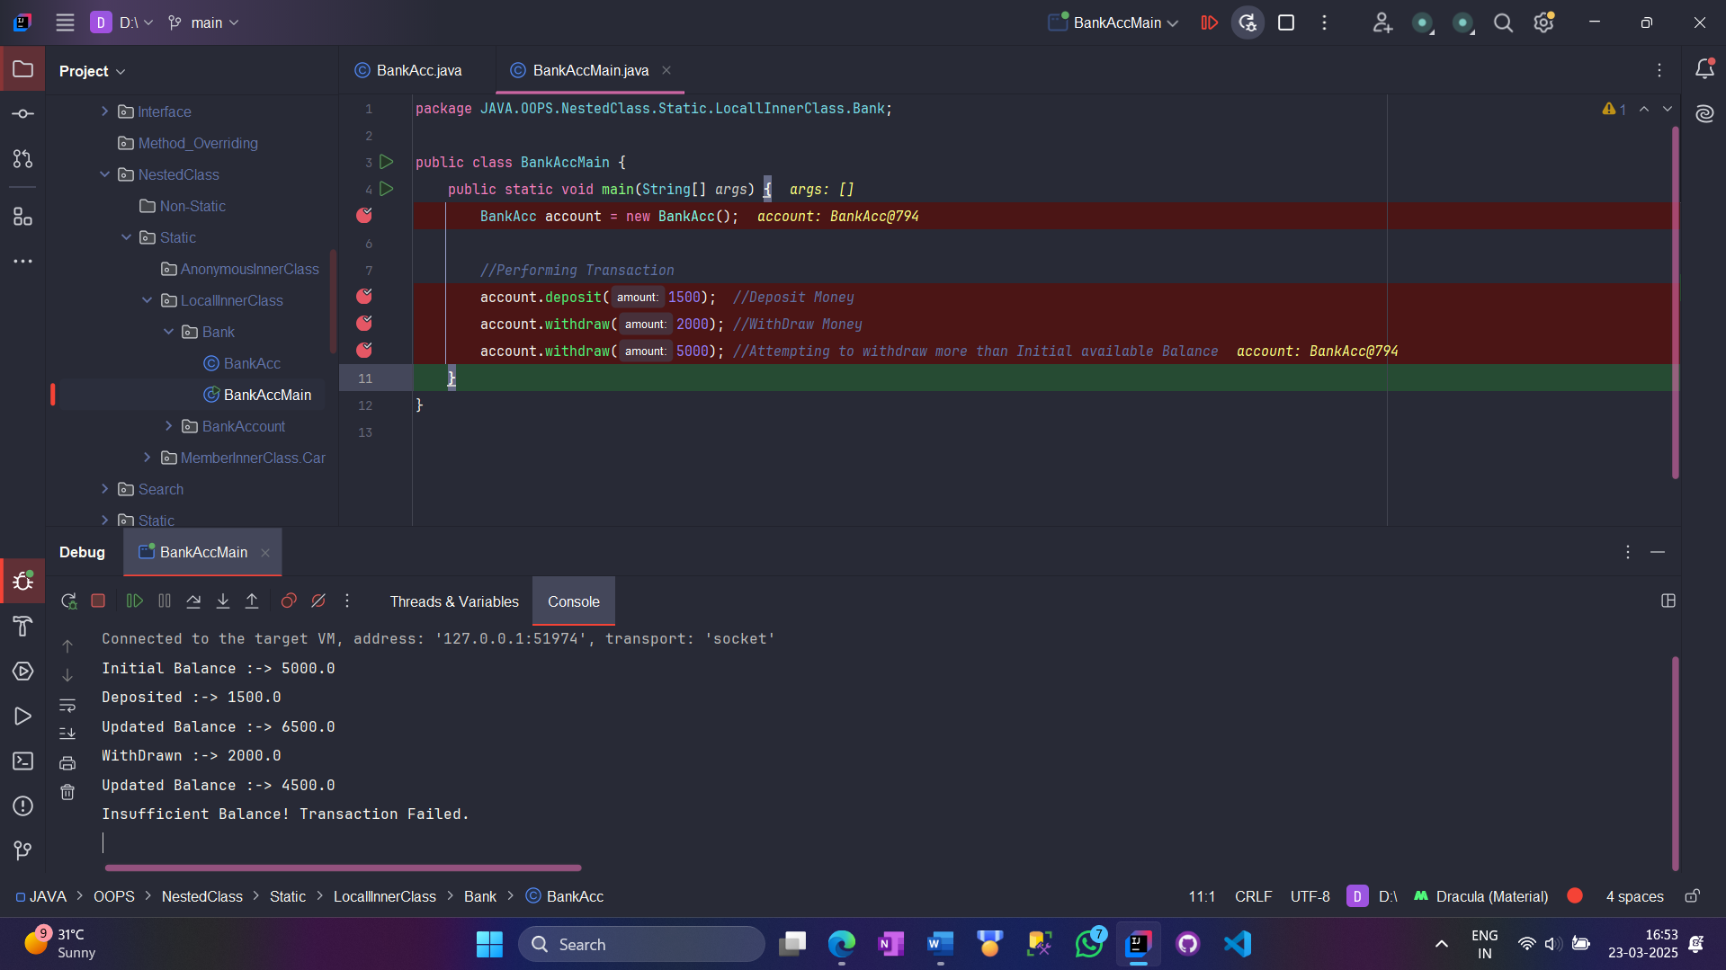

package JAVA.OOPS.NestedClass.Static.LocallInnerClass.Bank;  
  
public class BankAcc {  
 private double balance = 5000; *//Initial Balance  
  
 //Inner Class for Handling transactions* class Transaction {  
 void process(String *type*, double *amount*) {  
 if (*type*.equalsIgnoreCase("deposit")) {  
 balance += *amount*;  
 System.*out*.println("Deposited :-> " + *amount*);  
 } else if (*type*.equalsIgnoreCase("withdraw")) {  
 if (*amount* > balance) {  
 System.*out*.println("Insufficient Balance! Transaction Failed.");  
 return;  
 }  
 balance -= *amount*;  
 System.*out*.println("Withdrawn :-> " + *amount*);  
 } else {  
 System.*out*.println("Invalid transaction type!");  
 return;  
 }  
 System.*out*.println("Updated Balance :-> " + balance);  
 }  
 }  
  
 *//Method to perform Deposit* void deposit (double *amount*) {  
 Transaction transaction = new Transaction();  
 transaction.process("deposit", *amount*);  
 }  
  
 *//Method to perform withdrawal* void withdrawl(double *amount*) {  
 Transaction transaction = new Transaction();  
 transaction.process("withdraw",*amount*);  
  
 }  
}

package JAVA.OOPS.NestedClass.Static.LocallInnerClass.Bank;  
  
public class BankAccMain {  
 public static void main(String[] *args*) {  
 BankAcc account = new BankAcc();  
  
 *//Performing Transaction* account.deposit(1500); *//Depositing Money* account.withdrawl(2000); *//Withdrawing Money* account.withdrawl(5000); *//Attempting to withdraw more than available balance* }  
}

Deposited :-> 1500.0

Updated Balance :-> 6500.0

Withdrawn :-> 2000.0

Updated Balance :-> 4500.0

Insufficient Balance! Transaction Failed.

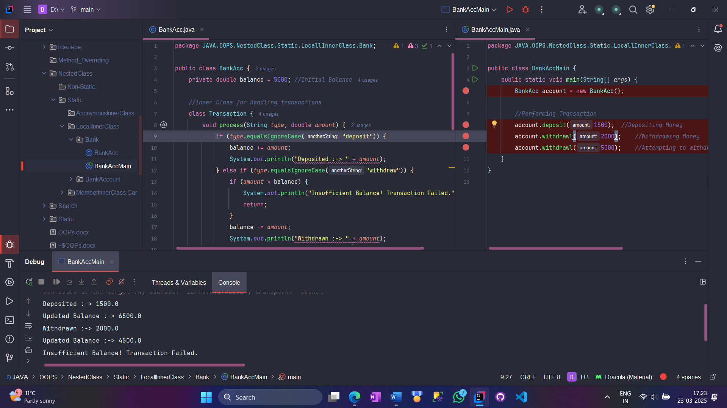

**4. Anonymous Inner Class**

* This is a **class without a name**, created for **one-time use**.
* It is mostly used to **override methods** of an interface or an abstract class.

**✅ Example**

abstract class Animal {

abstract void sound();

}

public class Main {

public static void main(String[] args) {

Animal obj = new Animal() { // Anonymous Class

void sound() {

System.out.println("Dog barks!");

}

};

obj.sound();

}

}

**🔹 Output:**

Dog barks!

package JAVA.OOPS.NestedClass.Static.AnonymousInnerClass.Animal;  
  
abstract class *Animal* {  
 abstract void sound();  
}

package JAVA.OOPS.NestedClass.Static.AnonymousInnerClass.Animal;  
  
public class animalMain {  
 public static void main(String[] *args*) {  
 *Animal* obj = new *Animal*() { //Anonymous Class  
 @Override  
 void sound() {  
 System.*out*.println("Roaring...");  
 }  
 };  
 obj.sound();  
 System.*out*.println("Obj instance of :-> " + obj.getClass().getName());  
 }  
}

Roaring...

Obj instance of :-> JAVA.OOPS.NestedClass.Static.AnonymousInnerClass.Animal.animalMain$1

**Quick Summary**

| **Type** | **Where is it defined?** | **Needs Outer Class Object?** | **Can Access Static Members?** | **Can Access Non-Static Members?** |
| --- | --- | --- | --- | --- |
| **Static Nested Class** | Directly inside a class | ❌ No | ✅ Yes | ❌ No |
| **Member Inner Class** | Directly inside a class | ✅ Yes | ✅ Yes | ✅ Yes |
| **Local Inner Class** | Inside a method | ✅ Yes | ✅ Yes | ✅ Yes (Final variables only) |
| **Anonymous Inner Class** | Inside a method or object creation | ✅ Yes | ✅ Yes | ✅ Yes |

**Real-World Example**

Let's say we have a **Bank** and we want to keep **Account details** inside the Bank.

class Bank {

private int balance = 10000;

class Account {

void showBalance() {

System.out.println("Current Balance: " + balance);

}

}

}

public class Main {

public static void main(String[] args) {

Bank bank = new Bank();

Bank.Account acc = bank.new Account();

acc.showBalance();

}

}

**🔹 Output:**

Current Balance: 10000

**Final Takeaways**

✅ **Nested Classes** help in organizing code better.  
✅ **Static Nested Classes** don't need an outer class object.  
✅ **Member Inner Classes** need an outer class object to work.  
✅ **Local Inner Classes** are defined inside methods.  
✅ **Anonymous Inner Classes** are used for quick one-time changes.

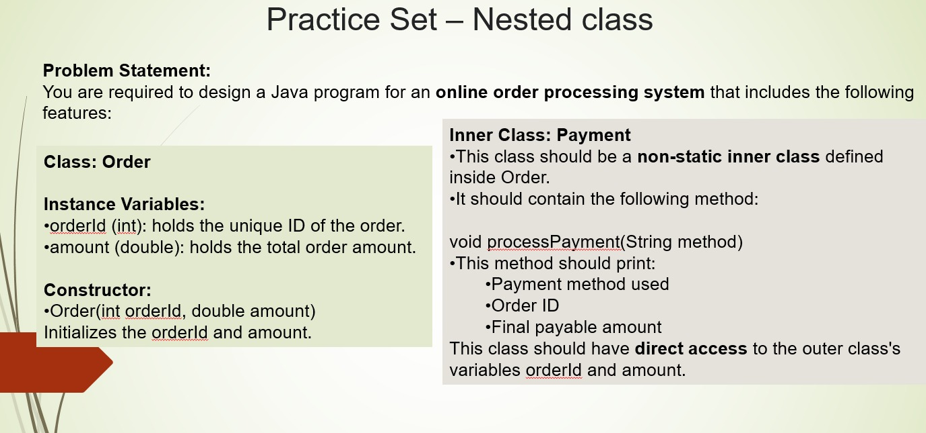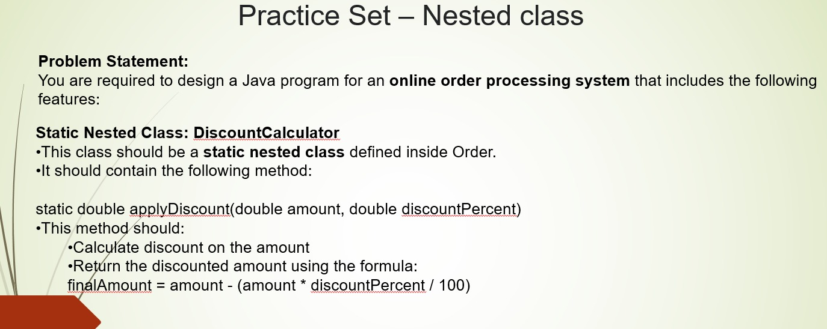

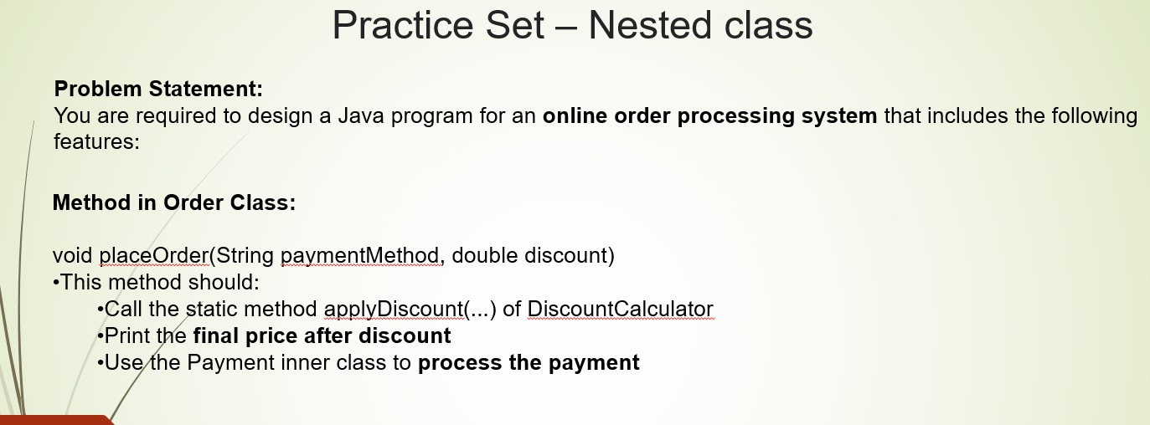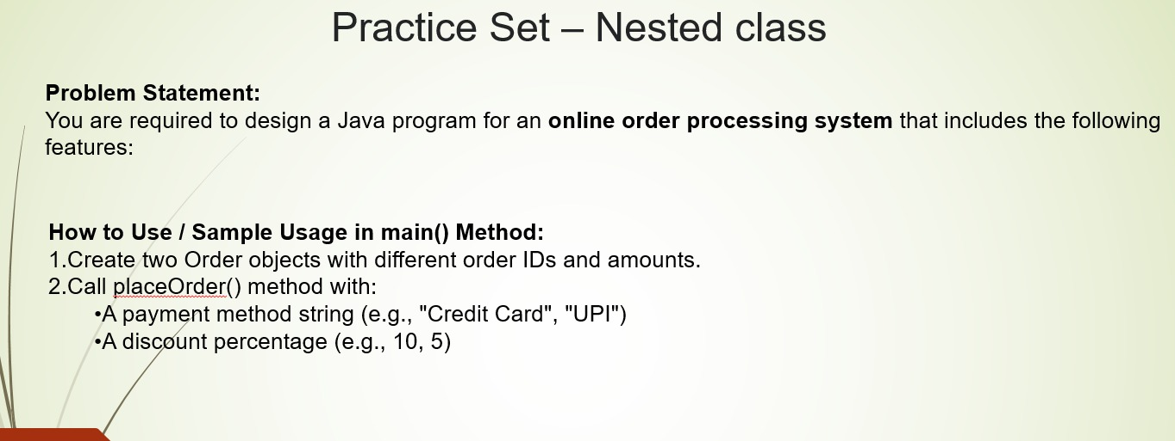

package JAVA.OOPS.NestedClass;  
  
import java.util.Scanner;  
  
public class Order {  
 private int orderID;  
 private double amount;  
  
 public Order (int *orderId*, double *amount*) {  
 this.orderID = *orderId*;  
 this.amount = *amount*;  
 }  
 class Payment {  
 void processPayment(String *method*) {  
 System.*out*.println("Payment method used :-> " + *method*);  
 System.*out*.println("OrderID :-> " + orderID);  
 System.*out*.println("Final Payable amount :-> " + amount);  
 }  
 }  
  
 static class DiscountCalculator {  
 static double applyDiscount (double *amount*, double *discountPercent*) {  
 return *amount* - (*amount* * *discountPercent*/100);  
 }  
 }  
  
 void placeOrder(String *paymentMode*, double *discount*) {  
 double discountedAmount = DiscountCalculator.*applyDiscount*(amount, *discount*);  
 System.*out*.println("Final Price After Discount :-> " + discountedAmount);  
 amount = discountedAmount;  
  
 Payment payment = new Payment();  
 payment.processPayment(*paymentMode*);  
 }  
 public static void main(String[] *args*) {  
 Scanner scanner = new Scanner(System.*in*);  
 System.*out*.print("Enter OrderID :-> ");  
 int orderID = scanner.nextInt();  
  
 System.*out*.print("Enter Amount :-> ");  
 double amount = scanner.nextDouble();  
  
 System.*out*.println("Enter Discount :-> ");  
 double discount = scanner.nextDouble();  
  
 Order order = new Order(orderID, amount);  
 System.*out*.println("---Order 1---");  
 order.placeOrder("Credit Card", discount);  
  
 System.*out*.println("---Order 2---");  
 order.placeOrder("Debit Card", discount);  
  
 scanner.close();  
 }  
}

Enter OrderID :-> 101

Enter Amount :-> 500

Enter Discount :->

2.0

---Order 1---

Final Price After Discount :-> 490.0

Payment method used :-> Credit Card

OrderID :-> 101

Final Payable amount :-> 490.0

---Order 2---

Final Price After Discount :-> 480.2

Payment method used :-> Debit Card

OrderID :-> 101

Final Payable amount :-> 480.2

***Static Variable and Methods***

**🔹 1. Static Variable – A Variable Shared by Everyone**

**🧠 What is it?**

In Java, a **static variable** is a variable that is shared by **all objects** of a class.  
It is created **only once** in memory and is shared by everyone.  
If one object changes it, the change will reflect in all other objects.

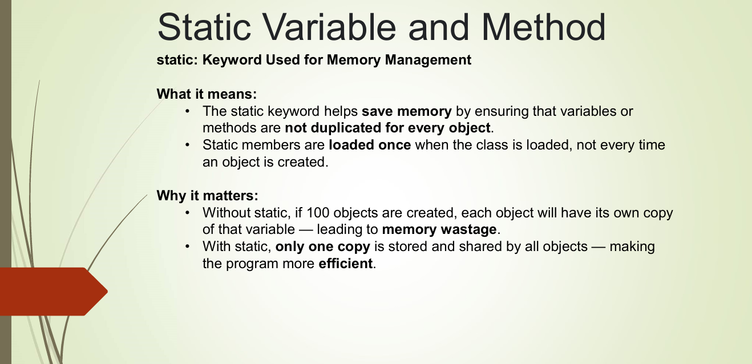

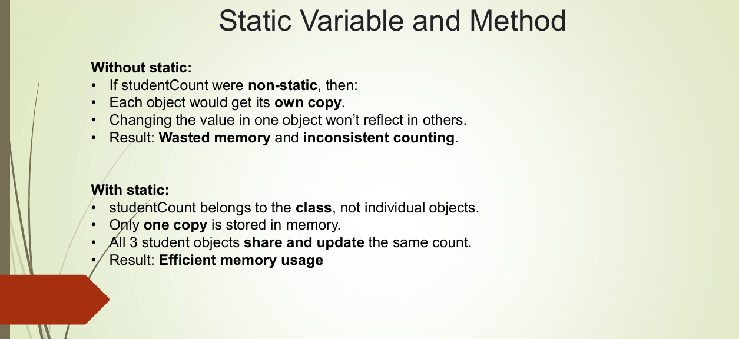

**🏠 Real Life Example:**

Let’s say you are creating a program about **students** in a school.

* Every student has their own:
  + name
  + roll number

But they all go to the **same school**, right?

So:

* name and rollNo → are different for each student (normal variables)
* schoolName → is same for everyone (static variable)

**💡 Why Use It?**

You use a **static variable** when you want to save memory and **share one value among all objects**.

**✅ Java Code Example for Static Variable:**

class Student {

String name;

int rollNo;

static String schoolName = "ABC School"; // static variable

Student(String name, int rollNo) {

this.name = name;

this.rollNo = rollNo;

}

void display() {

System.out.println(name + " - " + rollNo + " - " + schoolName);

}

}

**💬 Output:**

Student s1 = new Student("Amit", 101);

Student s2 = new Student("Riya", 102);

s1.display(); // Amit - 101 - ABC School

s2.display(); // Riya - 102 - ABC School

Now, if we do:

Student.schoolName = "XYZ School";

Then the output will become:

Amit - 101 - XYZ School

Riya - 102 - XYZ School

**🔹 2. Static Method – A Method You Can Call Without Object**

**🧠 What is it?**

A **static method** is a method that belongs to the **class**, not to the object.  
This means you can call it without creating an object.

It can only directly access **static variables and other static methods**.

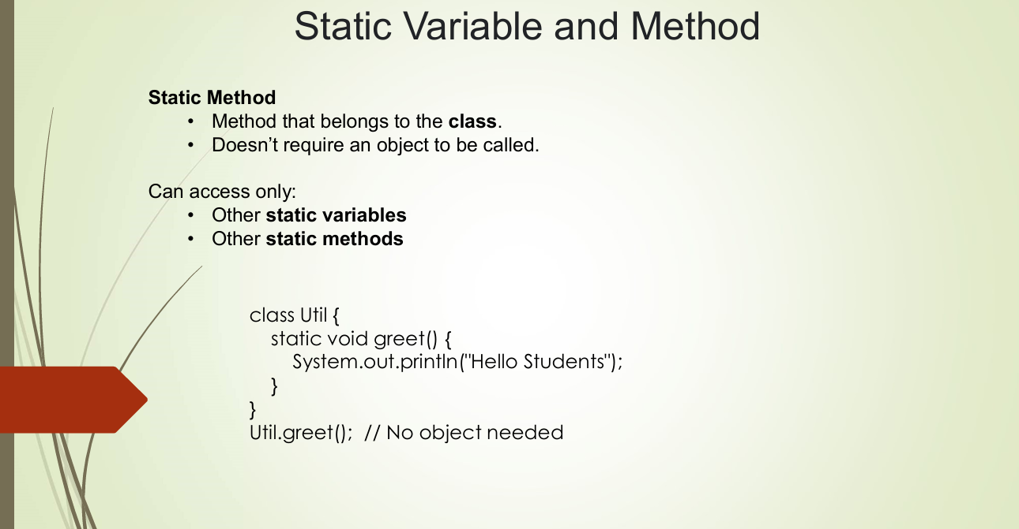

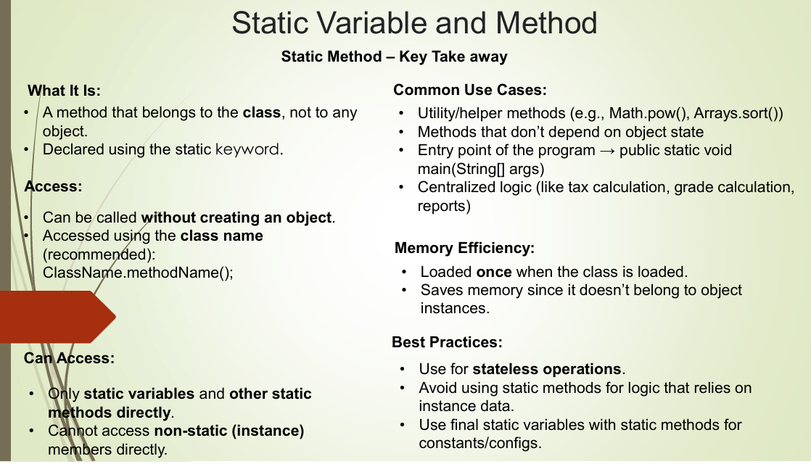

**🏠 Real Life Example:**

Let’s say you make a Calculator class.

You want to add numbers quickly without making an object.  
So you write a static method like:

Calculator.add(10, 20);

You don’t need to do:

Calculator c = new Calculator();

c.add(10, 20); // ❌ Not needed

**✅ Java Code Example for Static Method:**

class Calculator {

static int add(int a, int b) {

return a + b;

}

static int multiply(int a, int b) {

return a * b;

}

}

**💬 Usage:**

System.out.println(Calculator.add(5, 3)); // 8

System.out.println(Calculator.multiply(4, 2)); // 8

**🔄 Combining Both Static Variable and Static Method:**

class Student {

String name;

int rollNo;

static String school = "ABC School"; // static variable

Student(String name, int rollNo) {

this.name = name;

this.rollNo = rollNo;

}

void display() {

System.out.println(name + " - " + rollNo + " - " + school);

}

// static method to change school name

static void changeSchool(String newSchool) {

school = newSchool;

}

}

**💬 Main Method:**

public class Main {

public static void main(String[] args) {

Student s1 = new Student("Amit", 1);

Student s2 = new Student("Riya", 2);

s1.display(); // Amit - 1 - ABC School

s2.display(); // Riya - 2 - ABC School

// change school name using static method

Student.changeSchool("XYZ School");

s1.display(); // Amit - 1 - XYZ School

s2.display(); // Riya - 2 - XYZ School

}

}

**📋 Final Table Summary:**

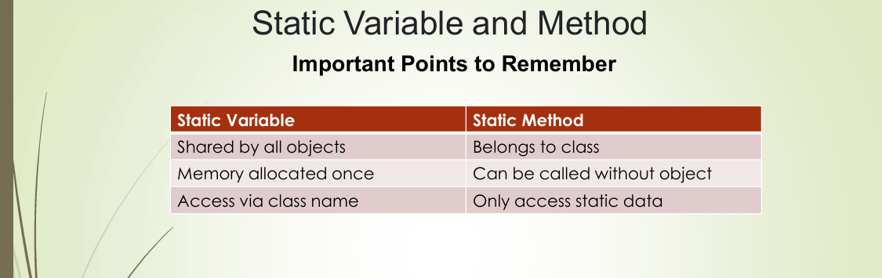

| **Feature** | **Static Variable** | **Static Method** |
| --- | --- | --- |
| Belongs to | Class (shared by all objects) | Class (not tied to any object) |
| Memory | Stored once | Stored once |
| Can access | Directly in static methods | Only static variables/methods |
| Access using | ClassName.variable or object | ClassName.method() |
| Object needed? | ❌ Not required | ❌ Not required |
| Use when | Value is same for all objects | Common utility method (like add, etc.) |
|  |  |  |
|  |  |  |

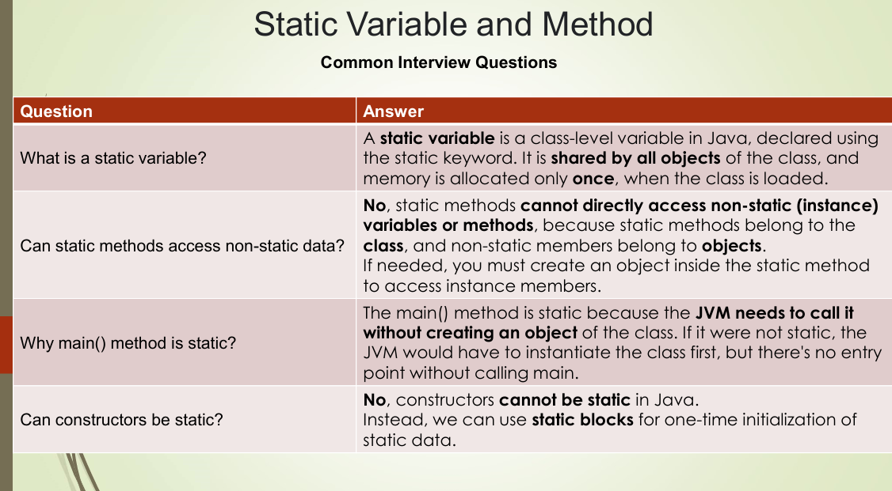

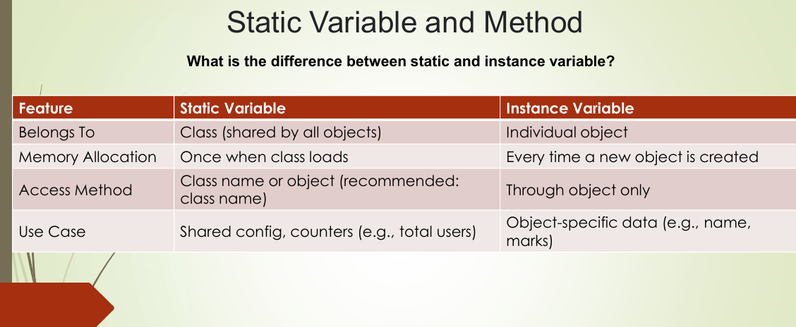

**🔹 What is a Static Block in Java?**

A **static block** is a block of code that runs **only once** when the class is loaded into memory — even **before the main() method** runs.

It is used to **initialize static variables** or perform setup operations when the class is first loaded.

**📌 Syntax:**

class MyClass {

static {

// Code here runs only once when the class is loaded

System.out.println("Static block is running...");

}

public static void main(String[] args) {

System.out.println("Main method is running...");

}

}

**💬 Output:**

Static block is running...

Main method is running...

**🧠 Why Use Static Block?**

You use a static block when:

* You want to **initialize static variables**.
* You want to run some code **before anything else** in the class.
* You want to **load a file**, **connect to a database**, or **read a configuration** when the class starts.

**🏠 Real-Life Example:**

Imagine when your **TV is turned on**, the company’s **logo appears first** before any channel comes up. That logo is like a static block — it runs once when the TV (class) is loaded.

**✅ Example with Static Variable Initialization**

class Bank {

static String bankName;

static {

// Static block to initialize static variable

bankName = "State Bank of India";

System.out.println("Bank loaded and name set!");

}

public static void main(String[] args) {

System.out.println("Bank Name: " + bankName);

}

}

**💬 Output:**

Bank loaded and name set!

Bank Name: State Bank of India

**🔄 Can I Have More Than One Static Block?**

Yes! If you write multiple static blocks, they run in the **order in which they appear** in the class.

class Example {

static {

System.out.println("Block 1");

}

static {

System.out.println("Block 2");

}

public static void main(String[] args) {

System.out.println("Main Method");

}

}

**💬 Output:**

Block 1

Block 2

Main Method

**📋 Final Summary:**

| **Feature** | **Static Block** |
| --- | --- |
| Runs when? | When class is **loaded** (before main) |
| Runs how many times? | Only **once** |
| Used for? | **Initialize static variables** or run startup code |
| Needs object? | ❌ No – runs without creating object |
| Can have multiple? | ✅ Yes, they run in the order written |
|  |  |

**🎁 Bonus Tip:**

You don’t need to call the static block — it runs **automatically** when the class is loaded.  
So if no object is created and main() is not used, the static block **still runs** (if class is used somehow).



package JAVA.OOPS.Static;  
  
public class Student {  
 static String *collegeName*;  
  
 public static void main(String[] *args*) {  
 *collegeName* = "Institute of Technology!";  
  
 System.*out*.println("College Name :-> " + *collegeName*);  
 }  
}

College Name :-> Institute of Technology!

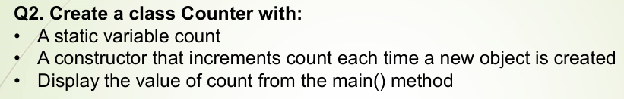

package JAVA.OOPS.Static;  
  
public class Counter {  
 static int *count* = 0;  
  
 Counter () {  
 *count*++;  
 }  
  
 public static void main(String[] *args*) {  
 Counter c1 = new Counter();  
 Counter c2 = new Counter();  
 Counter c3 = new Counter();  
  
 System.*out*.println("Numbers of Object created :-> " + *count*);  
 }  
}

Numbers of Object created :-> 3

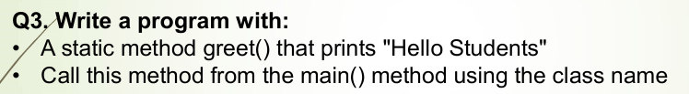

package JAVA.OOPS.Static;  
  
public class Greetings {  
 static void greet() {  
 System.*out*.println("Hello Students");  
 }  
 public static void main(String[] *args*) {  
 Greetings.*greet*();  
 }  
}

Hello Students

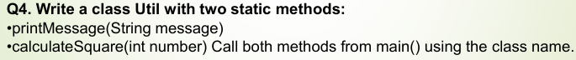

package JAVA.OOPS.Static;  
  
public class Util {  
 static void printMessage(String *message*) {  
 System.*out*.println("Message :-> " + *message*);  
 }  
  
 static int calculateSquare(int *n*) {  
 return *n* * *n*;  
 }  
 public static void main(String[] *args*) {  
 Util.*printMessage*("I'm Learning Java OOPs");  
 int square = Util.*calculateSquare*(10);  
 System.*out*.println("Square :-> " + square);  
 }  
}

Message :-> I'm Learning Java OOPs

Square :-> 100

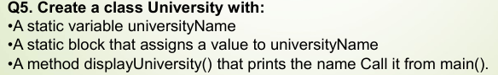

package JAVA.OOPS.Static.StaticBlock;  
  
public class University {  
 static String *universityName*;  
  
 static {  
 *universityName* = "Banaras Hindu University";  
 }  
 void displayUniversity () {  
 System.*out*.println("Name :-> " + *universityName*);  
 }  
 public static void main(String[] *args*) {  
 University university = new University();  
 university.displayUniversity();  
 }  
}

Name :-> Banaras Hindu University

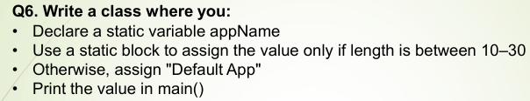

package JAVA.OOPS.Static.StaticBlock;  
  
public class Application {  
 static String *appName*;  
  
 static {  
 String name = "Players Unknown Battle Ground";  
  
 if (name.length() >= 10 && name.length() <= 30) {  
 *appName* = name;  
 } else {  
 *appName* = "Default App Name";  
 }  
 }  
 public static void main(String[] *args*) {  
 System.*out*.println("App Name :-> " + *appName*);  
 }  
}

App Name :-> Players Unknown Battle Ground

Final

**🔐 final in Java — Keyword of Restriction**

The final keyword is used to **restrict modification**. It can be applied to:

| **Usage** | **Meaning** |
| --- | --- |
| **Variable** | Once assigned, its value cannot be changed (like a constant). |
| **Method** | Cannot be overridden by a subclass. |
| **Class** | Cannot be inherited (i.e., no class can extend it). |

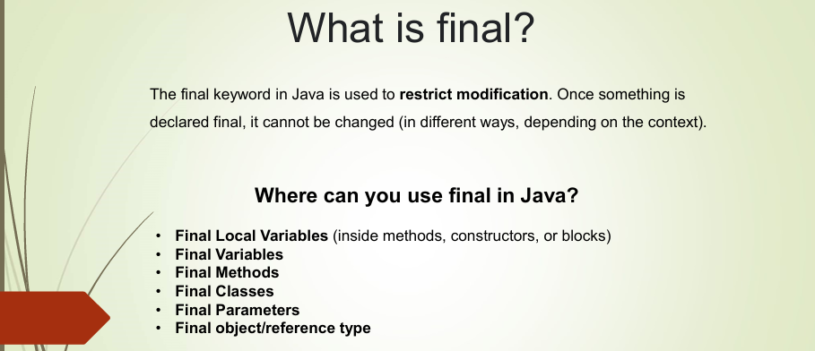

**✅ 1. final Variable**

Acts like a **constant**. You **must initialize** it either during declaration or inside a constructor (if it's a non-static final field).

final int x = 10;

x = 20; // ❌ Error: Cannot assign a value to final variable 'x'

**💡 Final Reference:**

For objects:

final Student s = new Student();

s = new Student(); // ❌ Error: Can't reassign the reference

s.name = "Aryan"; // ✅ OK: Can change internal data

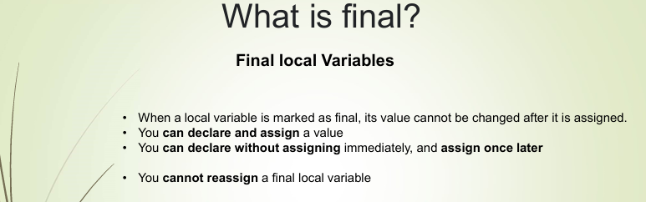

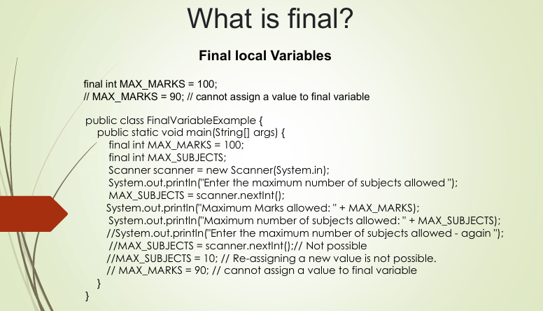

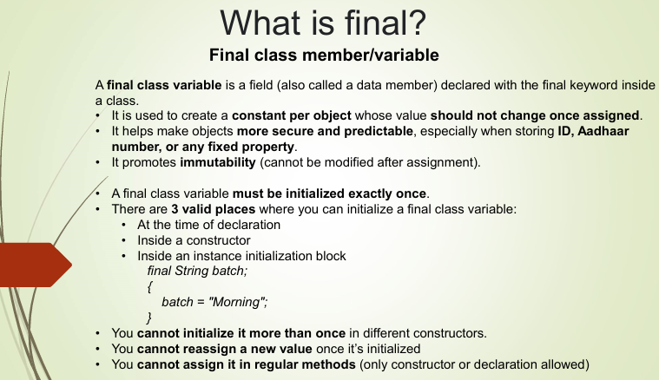

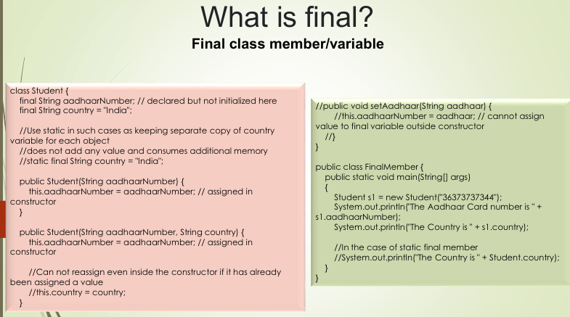

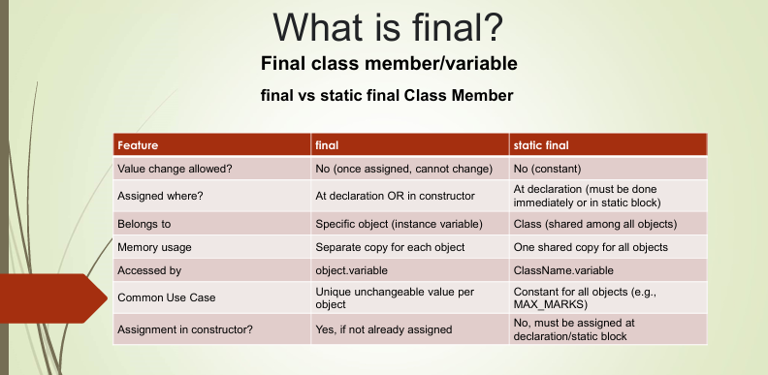

**✅ 2. final Method**

Prevents overriding in subclasses.

class A {

final void display() {

System.out.println("Hello");

}

}

class B extends A {

void display() { // ❌ Error: Cannot override final method

System.out.println("Hi");

}

}

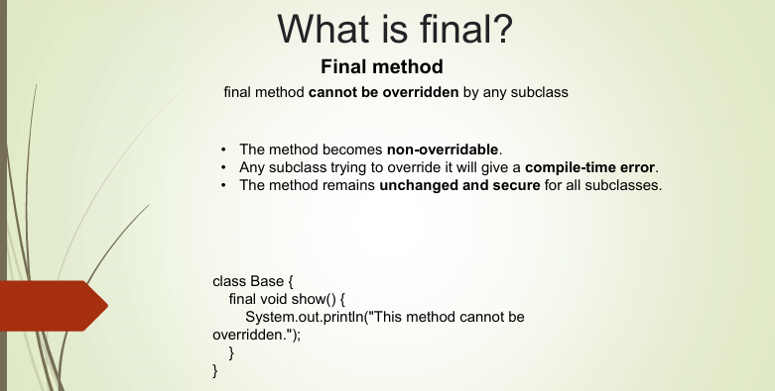

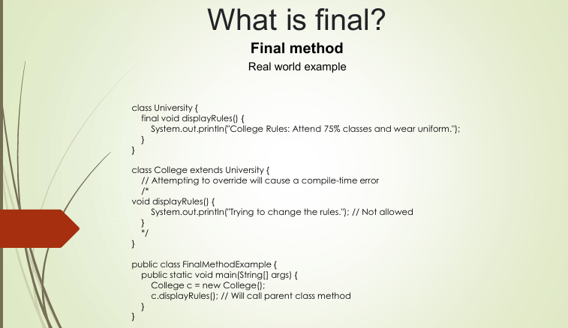

**✅ 3. final Class**

Prevents inheritance.

final class Vehicle {

void run() {

System.out.println("Running...");

}

}

class Car extends Vehicle { // ❌ Error: Cannot inherit from final class

}

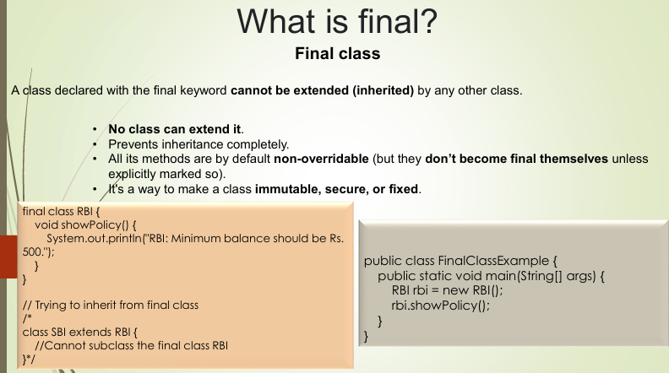

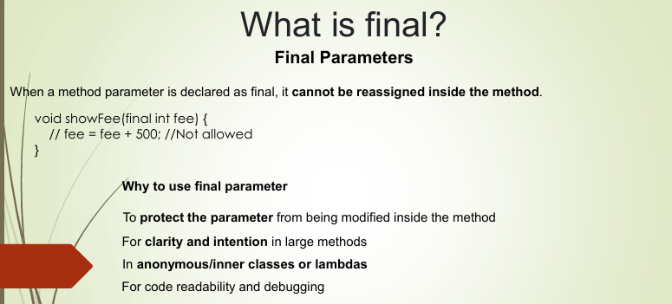

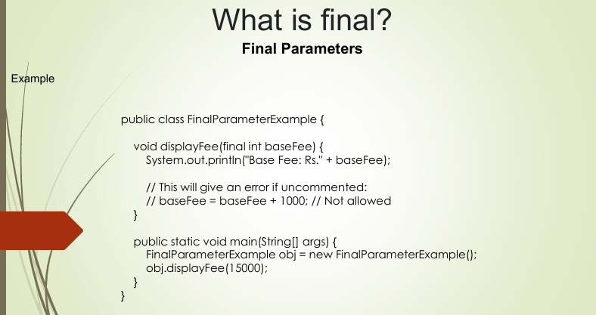

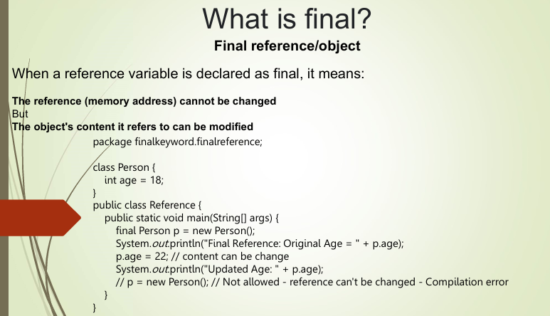

**🧠 Key Points:**

* A final variable = constant (no reassignment).
* A final method = cannot be overridden (useful in securing method logic).
* A final class = cannot be extended (used for security & immutability, like String class).
* final is different from finally (exception handling) and finalize() (GC method).

**⚙️ Use Cases:**

| **Where** | **Why** |
| --- | --- |
| Constants | To declare fixed values like PI, MAX_SIZE, etc. |
| Secure Logic | Prevent method overriding to protect critical business logic. |
| Immutable Obj | Combine final with custom class design to build immutable classes. |
|  |  |

